

**FLIGHT RESERVATION SYSTEM**

**A Software Tools Project Report by**

**Name Registration No Roll No Signature**

Aniruddh Shukla 151440110003 14400115003

Natasha Choradia 151440110017 14400115016

**4th Semester (2016-2017)**



Department of Computer Science and Engineering

Neotia Institute of Technology Management And Science

Jhinga, Amira, D.H.Road, 24-Parganas (S) – 743368, WB (INDIA)

**May,2017**



**Certificate**

This is to certify that the work contained in this report titled **‘Flight Reservation System’** is the original work done by **Aniruddh Shukla (14400115003)** and **Natasha Choradia (14400115016)** under our supervision in the **Software Tools Lab (CS 492)** in partial fulfillment of the degree of Bachelor of Technology in Computer Science & Engineering of **Neotia Institute of Technology Management And** **Science**, Jhinga, WB in the 4th semester of the academic batch **2015-2019**.

**Project Supervisors**

Department of Computer Science and Engineering

**Head of the Department**

Department of Computer Science and Engineering

Neotia Institute of Technology Management And Science

Jhinga, West Bengal

**Date :**

**Place :**



**Acknowledgements**

We the students of computer science are submitting this project to the CSE department for the software tools lab in the 4th semester.

This project gave us the chance to develop the communication analyzing and the future estimation skills of us about which we were unaware of, during the preparation of this project.

Since a project is to be the touchstone of testing the student’s ability as technician, its successful completion is a matter of great pleasure for us. It is not possible for us to cover all aspects of this project with details and no extreme limits.

We have attempted all the important points with sufficient knowledge. Bookish knowledge, formulas and unnecessary definitions have been avoided.

We are thankful to NITMAS for providing us the project in their organization between the environments of the project work. Also we are thankful to our professors for guiding us.



**Contents**

* Certificates
* Acknowledgements
* Introduction
* Hardware and Software Configuration
* Purpose of the project
* Instructions
* Screenshots of the frames
* Database screenshots
* Source code
* Conclusion
* Bibliography



**Introduction**

A **‘Flight Reservation System’** is part of the so-called passenger service systems (PSS), which are applications supporting the direct contact with the passenger. This project uses Visual Basics as its platform and Microsoft Access for its database management.

It enables the user to do the things such as search for flights between two cities on specified date, choose a flight based on the details, reservation of flights and cancellation of reservation.

The system allows the passenger to search for flights between two travel cities for a particular date. The system displays all the flight details such as flight number, price, availability of seats, check PNR status etc.

To book a flight the system asks for the user name and password and the details of other person, travelling with the user. After the booking the system updates the user details in the database.

The system also, allows the admin to change the flight timings, add or remove flights, increase the number of seats and so on.



**Hardware and Software Configurations**

* **Hardware Specifications**
* Intel i3/i5/i7 Processor
* 2/4 GB RAM
* 1 GB Hard Disk
* Monitor
* Colored Printer
* **Software Specifications**
* Microsoft Visual Basic 2015
* Microsoft Access 2010
* Browsers : Google Chrome, UC Browser, Mozilla Firefox
* **Operating System**
* Windows 7/8/8.1/10



**flowchart**

**Check Ticket Status**

**Cancel Ticket**

**Enter**

**PNR**

**Print**

**Ticket**

**Payment**

**Gateway**

**Book**

**Seats**

**Traveller**

**Details**

**Booking**

**Page**

**Book**

**Ticket**

**Book Ticket or Check Ticket Status or Cancel Ticket**

**Login**

**Login Page**

**Registartion Form**

**Register**

**Register or Login**

**Operator**

**Admin functions (Add Flight,** **Remove Flight, Add Seats, Remove User, Change Fare, Booking Details)**

**Login**

**Admin**

**How do you want to continue?**



**Instructions**

For booking ticket, user has to sign in or register using sign-up form. Under this menu, user will have to enter user name, password and other personal details to access this system. After successful registration, user can login by using their used ID and password, used during registration process. After logging in the user need to provide the Source and Destination, select appropriate date. Valid flight names will appear along with time, which the user has to choose. The total cost shall also be displayed when the number of seats is selected.

After booking the ticket, user will be provided with a unique PNR number, that is generated automatically. User can use this PNR number to check the ticket status or cancel tickets. After displaying the cost, a fake payment gateway appears and ‘Print Ticket’ option appears.



**Screenshots**

**of**

**the frames**

**Welcome**

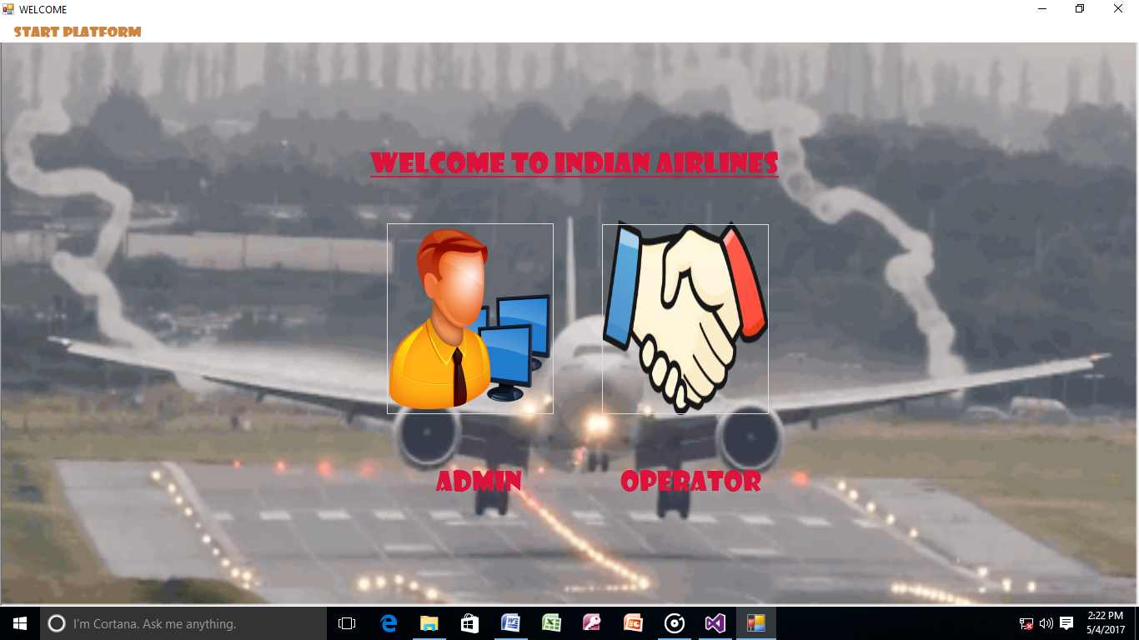

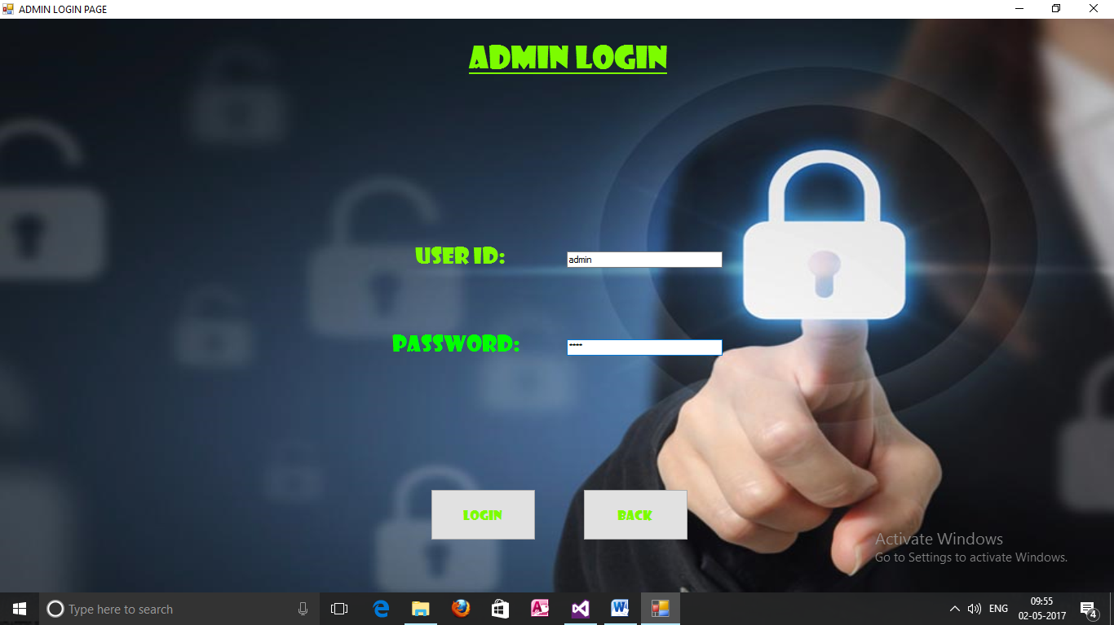**Admin login page**

**Admin 1**

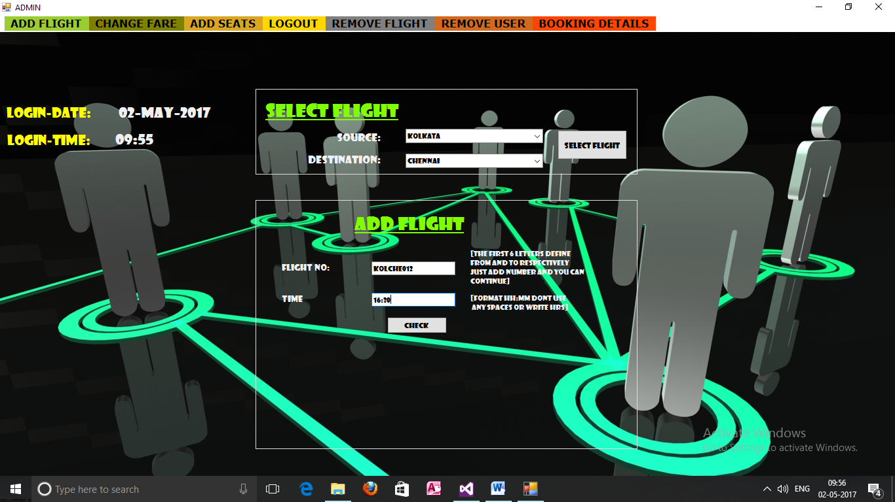

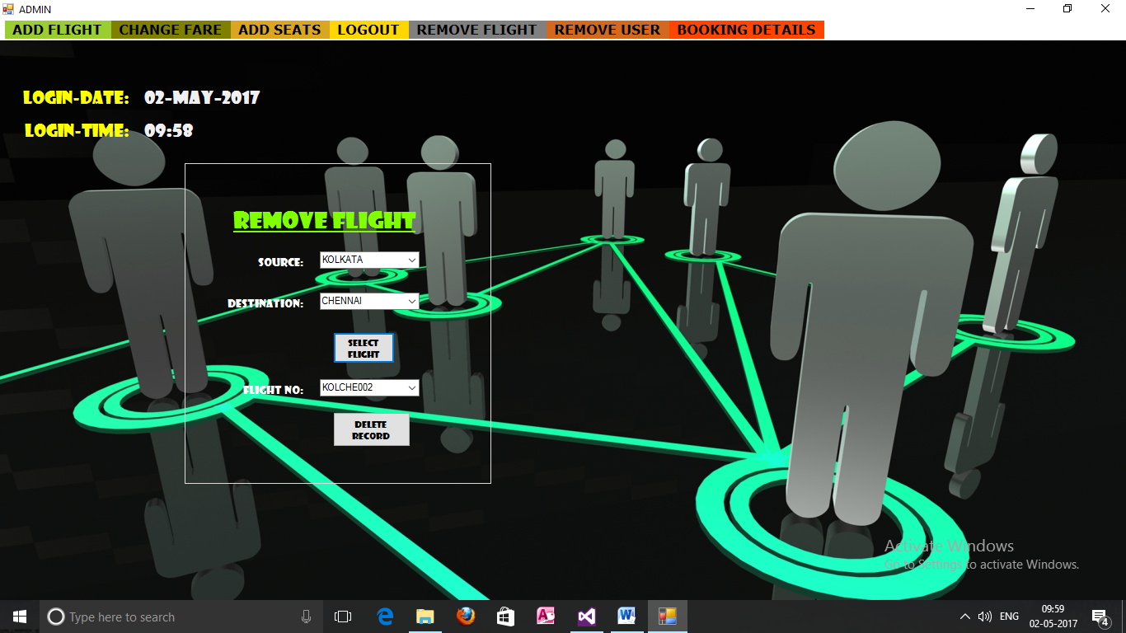**Admin 2**

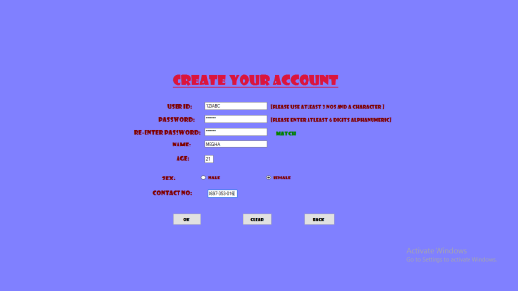**registration form**

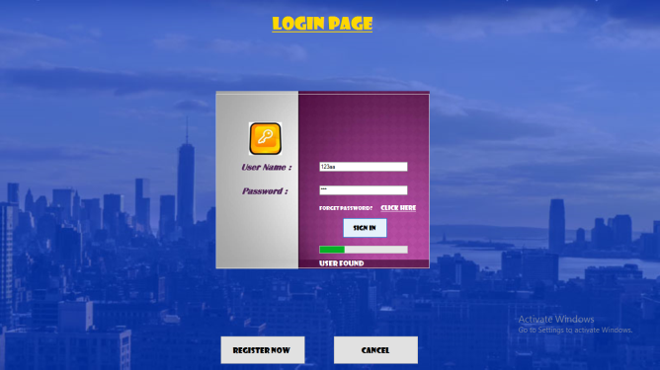**login page**

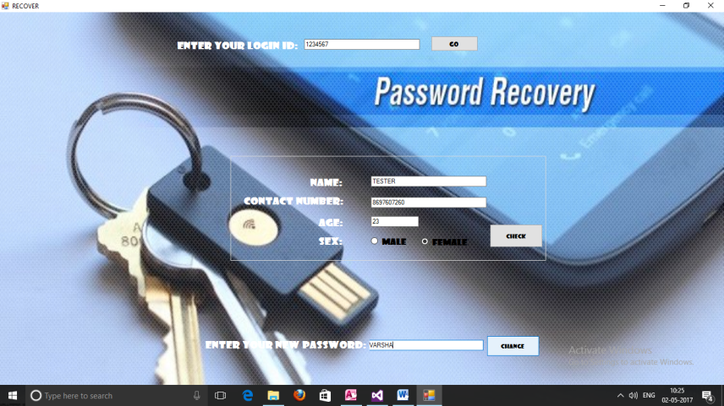**Password recovery**

**Booking page**

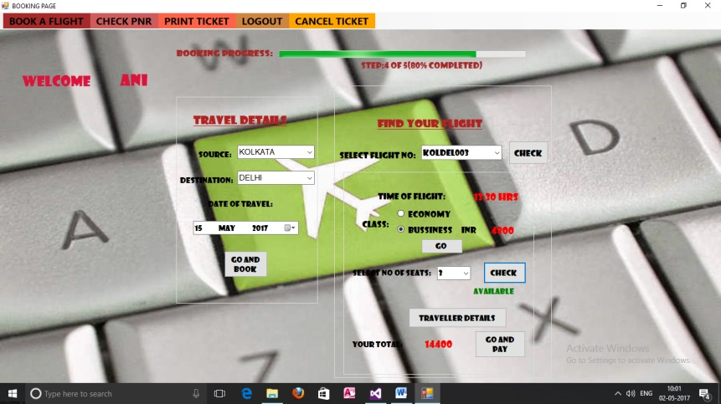

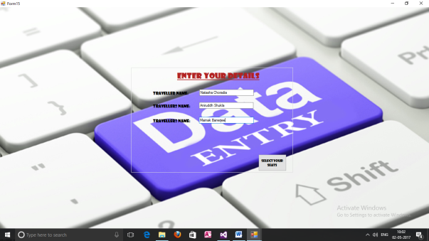**Traveller details**

**Seat selection**

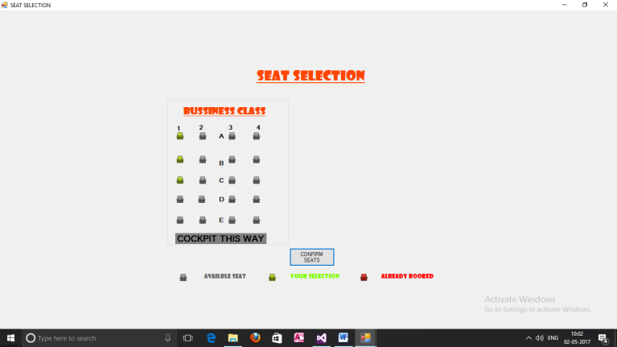

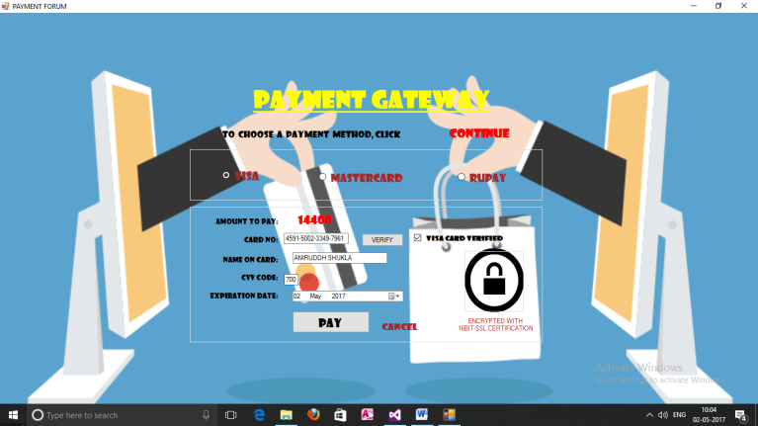**Payment forum**

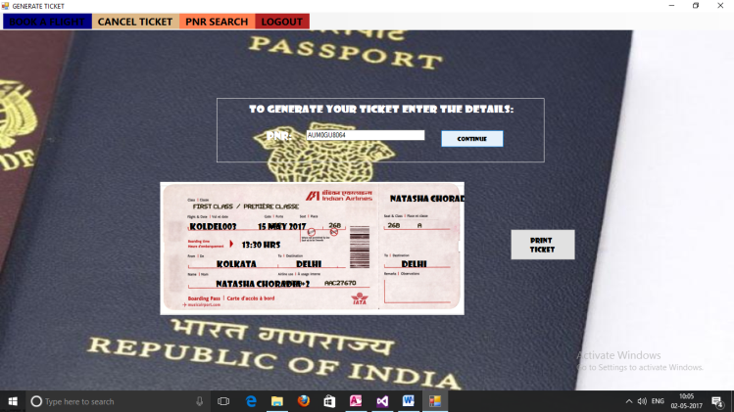**Print ticket**

**Pnr status**

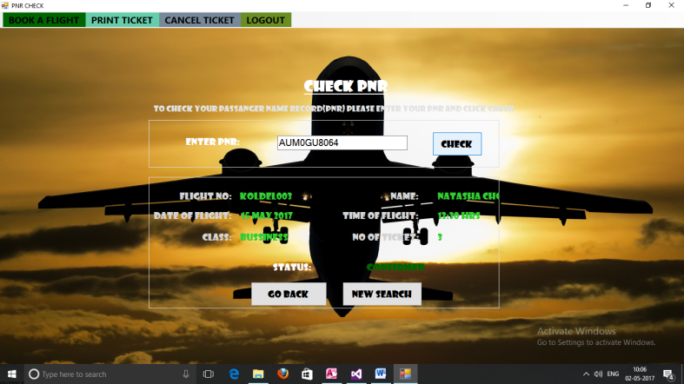

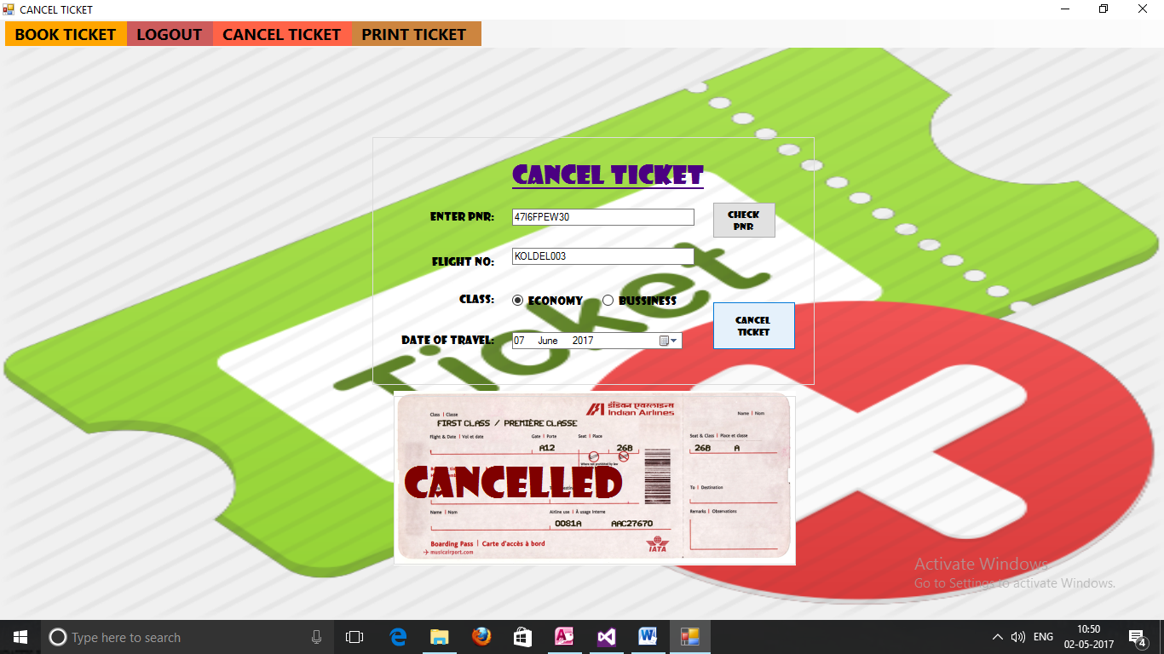**Cancel ticket**



**Database**

**Screenshots**

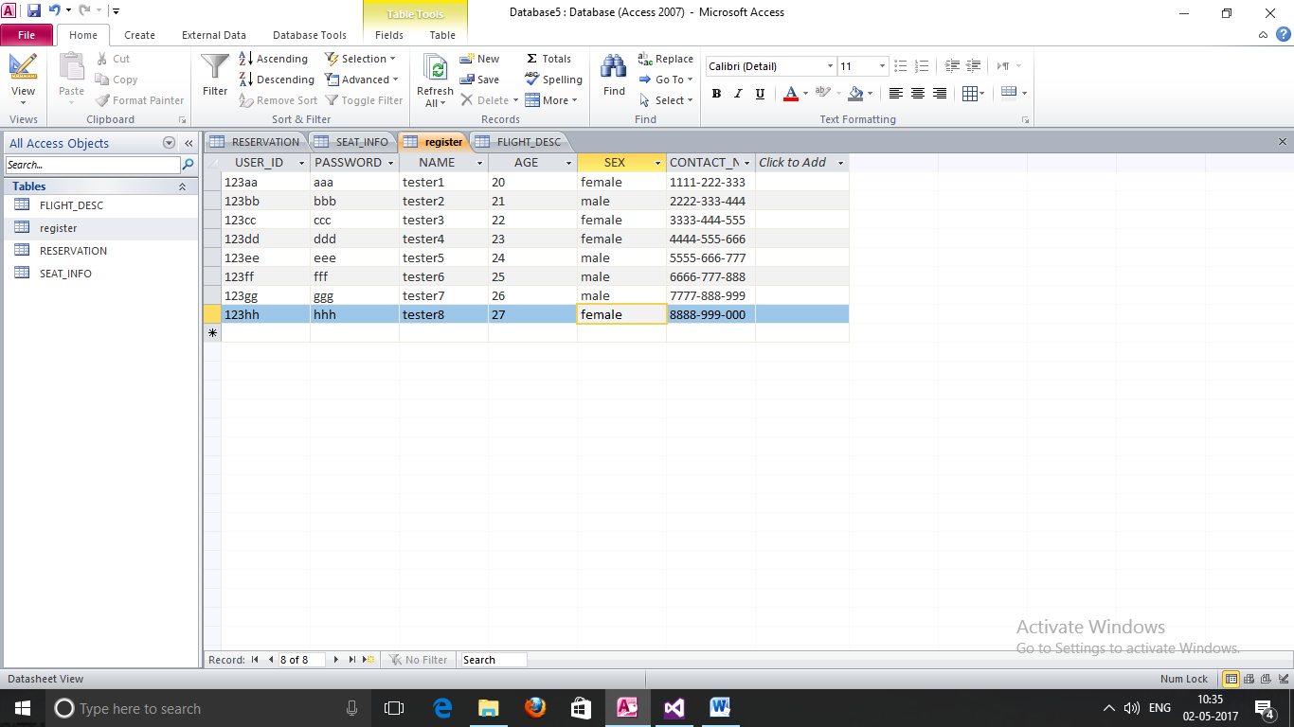**register**

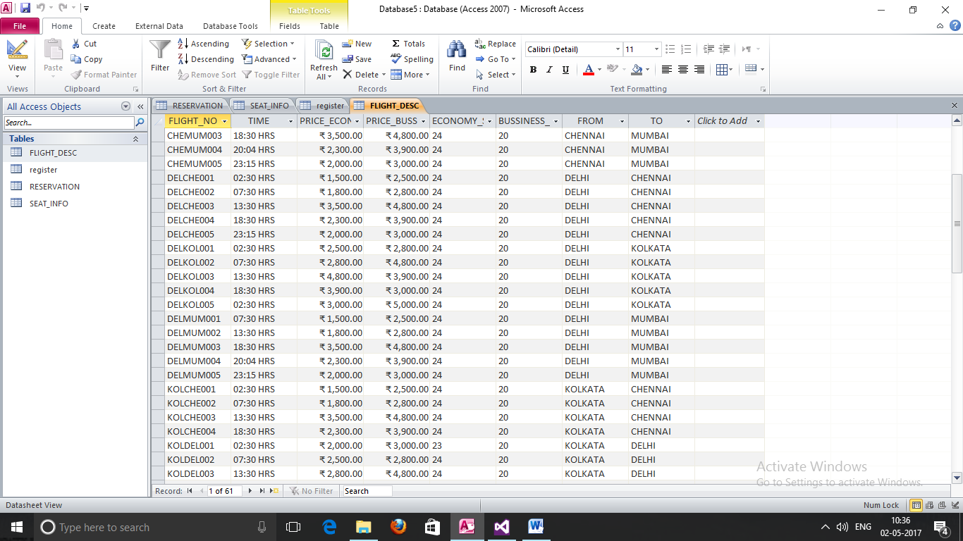**Flight description**

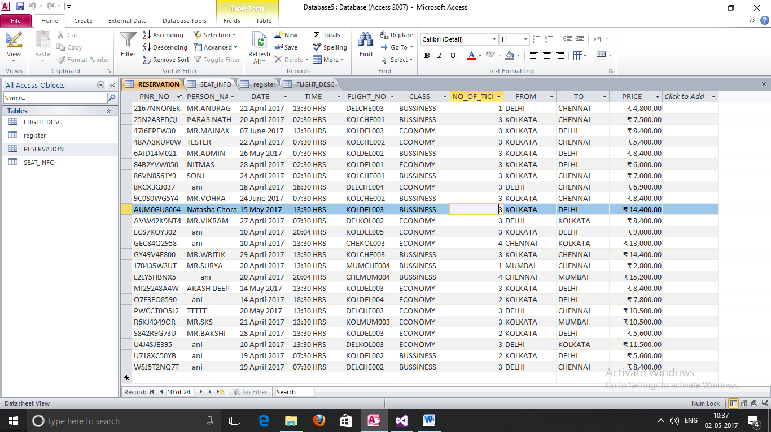 **reservation**

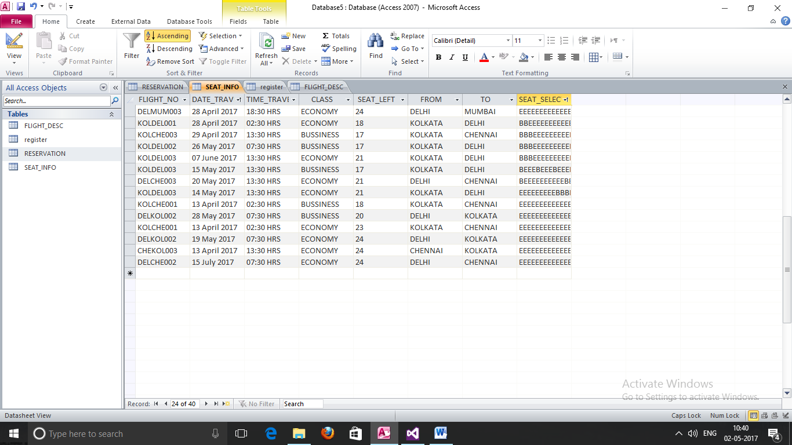**Seat information**



**Handout**

**Step 1:** Click on **Start Platform** and select **Entry**

**Step 2:** Select **Operator**

**Step 3:** Click on **Resister Now**

**Step 4:** Fill the Registration Form and click on **Ok**

**Step 5:** Now login using the ‘User Name’ and ‘Password’ that you provided in the Registration Form and click on **Sign In**

**Step 6:** Click on **Book A Ticket** to book a ticket

**Step 7:** Select a city each from the **Source** and **Destination** dropbox.

**Step 8:** Select an appropriate date and click on **Go and Book**

**Step 9:** Select a flight and click on **Check** to know the timing

**Step 10:** Select class to know the price of each seat and click on **Go**

**Step 11:** Select the number of seats and click on **Check** to check if seats are available for that particular flight

**Step 12:** Click on **Traveller Details** and provide the names of the passenger and click on **Select Your Seats** to proceed further

**Step 13:** Choose seats and click on **Confirm Seats**

**Step 14:** Note the payable amount and Click on **Go and Pay**

**Step 15:** Note the PNR generated for further functions

**Step 16:** Choose a Payment Method and provide the necessary details

**Step 17:** Enter the PNR number to **Check Stauts**, **Print** or **Cancel Ticket**



**Source**

**Code**

**WELCOME FORM:**

Public Class Form1

Private Sub Form1_Load(sender As Object, e As EventArgs) Handles MyBase.Load

PictureBox1.Image = Image.FromFile(Application.StartupPath & "\2.gif")

GroupBox1.Parent = PictureBox1

GroupBox2.Parent = PictureBox1

Label1.Parent = PictureBox1

Label2.Parent = PictureBox1

Label3.Parent = PictureBox1

WindowState = FormWindowState.Maximized

GroupBox1.Visible = False

GroupBox2.Visible = False

Label1.Visible = False

Label2.Visible = False

Label3.Visible = False

End Sub

Private Sub ENTRYToolStripMenuItem_Click(sender As Object, e As EventArgs) Handles ENTRYToolStripMenuItem.Click

GroupBox1.Visible = True

GroupBox2.Visible = True

Label1.Visible = True

Label2.Visible = True

Label3.Visible = True

End Sub

Private Sub EXITToolStripMenuItem_Click(sender As Object, e As EventArgs) Handles EXITToolStripMenuItem.Click

End

End Sub

Private Sub Label2_Click(sender As Object, e As EventArgs) Handles Label2.Click

Form2.Show()

End Sub

Private Sub Label3_Click(sender As Object, e As EventArgs) Handles Label3.Click

Form3.Show()

End Sub

End Class

**ADMIN LOGIN:**

Public Class Form2

Private Sub Form2_Load(sender As Object, e As EventArgs) Handles MyBase.Load

Form1.Hide()

WindowState = FormWindowState.Maximized

End Sub

Private Sub Button1_Click(sender As Object, e As EventArgs) Handles Button1.Click

If (TextBox1.Text = "") Then

MsgBox("PLEASE ENTER USER ID :/")

ElseIf (TextBox2.Text = "") Then

MsgBox("PLEASE ENTER PASSWORD :/")

End If

If (TextBox1.Text = "admin" AndAlso TextBox2.Text = "1234") Then

Form11.Show()

Hide()

Else

MsgBox("SORRY MATE!!!EITHER YOU'RE NOT AN ADMIN :(")

TextBox1.Text = ""

TextBox2.Text = ""

End If

End Sub

Private Sub Button2_Click(sender As Object, e As EventArgs) Handles Button2.Click

Hide()

Form1.Show()

End Sub

End Class

**USER LOGIN:**

Imports System.Data.OleDb

Public Class Form3

Dim PROVIDER As String

Dim DATAFILE As String

Dim CONNSTRING As String

Dim MYCONNECTION As OleDbConnection = New OleDbConnection

Private Sub Form3_Load(sender As Object, e As EventArgs) Handles MyBase.Load

Form1.Hide()

WindowState = FormWindowState.Maximized

End Sub

Private Sub Button2_Click(sender As Object, e As EventArgs) Handles Button2.Click

form4.Show()

Hide()

End Sub

Private Sub Button1_Click(sender As Object, e As EventArgs) Handles Button1.Click

PROVIDER = "Provider=Microsoft.ACE.OLEDB.12.0;Data Source="

DATAFILE = "C:\Users\LENOVO\Desktop\FLT\Database5.accdb"

CONNSTRING = PROVIDER & DATAFILE

MYCONNECTION.ConnectionString = CONNSTRING

MYCONNECTION.Open()

Dim cmd As New OleDbCommand("SELECT * FROM REGISTER WHERE USER_ID='" & Convert.ToString(TextBox1.Text) & "' AND PASSWORD='" & Convert.ToString(TextBox2.Text) & "'", MYCONNECTION)

Dim dr As OleDbDataReader = cmd.ExecuteReader

Dim USER_ID As Boolean = False

Dim NAME As String = ""

Dim LASTNAME As String = ""

While dr.Read

USER_ID = True

NAME = dr("NAME").ToString

End While

Label4.Visible = True

ProgressBar1.Visible = True

Label4.Text = ""

If USER_ID = True Then

Form5.Label1.Text = " " & NAME & " "

Timer2.Start()

Else

Timer1.Start()

End If

MYCONNECTION.Close()

End Sub

Private Sub Button3_Click(sender As Object, e As EventArgs) Handles Button3.Click

Hide()

Form1.Show()

End Sub

Private Sub Label3_Click(sender As Object, e As EventArgs) Handles Label3.Click

If (TextBox1.Text = "") Then

MsgBox("PLEASE ENTER YOUR ID TO CONTINUE")

Else

TextBox1.Text = ""

TextBox2.Text = ""

Form13.Show()

Hide()

End If

End Sub

Private Sub Timer2_Tick(sender As Object, e As EventArgs) Handles Timer2.Tick

ProgressBar1.Visible = True

ProgressBar1.Increment(10)

If ProgressBar1.Value > 10 And ProgressBar1.Value < 30 Then

Label4.Text = "CONNECTING TO SERVER.."

ElseIf ProgressBar1.Value > 30 And ProgressBar1.Value < 60 Then

Label4.Text = "USER FOUND"

ElseIf ProgressBar1.Value > 60 And ProgressBar1.Value < 80 Then

Label4.Text = "VERIFYING PASSWORD "

ElseIf ProgressBar1.Value > 80 And ProgressBar1.Value < 90 Then

Label4.Text = "AUTHENTICATION SUCCESSFUL"

ElseIf ProgressBar1.Value = 100 Then

Label4.Text = "AUTHENTICATION SUCCESSFUL"

Form5.Show()

Hide()

Timer2.Enabled = False

ProgressBar1.Value = 0

ProgressBar1.Value = False

ProgressBar1.Visible = False

Label4.Text = ""

TextBox1.Text = ""

TextBox2.Text = ""

End If

End Sub

Private Sub Timer1_Tick(sender As Object, e As EventArgs) Handles Timer1.Tick

ProgressBar1.Enabled = True

ProgressBar1.Increment(10)

If ProgressBar1.Value > 10 And ProgressBar1.Value < 30 Then

Label4.Text = "CONNECTING TO SERVER.."

ElseIf ProgressBar1.Value > 30 And ProgressBar1.Value < 60 Then

Label4.Text = "CONNECTING .."

ElseIf ProgressBar1.Value > 60 And ProgressBar1.Value < 90 Then

Label4.Text = "CHECKING USER"

ElseIf ProgressBar1.Value = 100 Then

Label4.Text = "AUTHENTICATION FAILED"

ProgressBar1.Value = 0

ProgressBar1.Value = False

ProgressBar1.Visible = False

Timer1.Enabled = False

End If

End Sub

End Class

**USER REGISTRATION:**

Imports System.Data.OleDb

Public Class form4

Dim PROVIDER As String

Dim DATAFILE As String

Dim CONNSTRING As String

Dim MYCONNECTION As OleDbConnection = New OleDbConnection

Dim MYCONN As OleDbConnection = New OleDbConnection

Dim KTR As String

Private Sub form4_load(ByVal sender As System.Object, ByVal e As System.EventArgs) Handles MyBase.Load

WindowState = FormWindowState.Maximized

TextBox3.Text = ""

TextBox4.Text = ""

TextBox5.Text = ""

TextBox6.Text = ""

MaskedTextBox1.Text = ""

MaskedTextBox2.Text = ""

Label9.Visible = False

Label10.Visible = False

Button2.Enabled = False

End Sub

Private Sub Button2_Click(ByVal sender As System.Object, ByVal e As System.EventArgs) Handles Button2.Click

If TextBox3.Text = "" Or TextBox4.Text = "" Or TextBox5.Text = "" Or TextBox6.Text = "" Or MaskedTextBox1.Text = "" Or MaskedTextBox2.Text = "" Then

MessageBox.Show("Please complete the required fields..", "Authentication Error", MessageBoxButtons.OK, MessageBoxIcon.Error)

Exit Sub

Else

If (RadioButton1.Checked = True) Then

KTR = RadioButton1.Text

ElseIf (RadioButton2.Checked = True) Then

KTR = RadioButton2.Text

Else

MessageBox.Show("Please complete the required fields..", "Authentication Error", MessageBoxButtons.OK, MessageBoxIcon.Error)

Exit Sub

End If

PROVIDER = "Provider=Microsoft.ACE.OLEDB.12.0;Data Source="

DATAFILE = "C:\Users\LENOVO\Desktop\FLT\Database5.accdb"

CONNSTRING = PROVIDER & DATAFILE

MYCONNECTION.ConnectionString = CONNSTRING

MYCONN.ConnectionString = CONNSTRING

MYCONN.Open()

Dim cm As New OleDbCommand("Select * from [REGISTER] WHERE [USER_ID]='" & TextBox3.Text & "'", MYCONN)

Dim dr As OleDbDataReader = cm.ExecuteReader

Dim BOL As Boolean = False

While dr.Read

BOL = True

End While

If BOL = True Then

MsgBox("USER ID ALREADY IN USE TRY A DIFFERENT ONE")

dr.Close()

MYCONN.Close()

Exit Sub

End If

MYCONN.Close()

If (MaskedTextBox1.Text.Length = 12) Then

Button2.Focus()

Else

MsgBox("MOBILE NUMBER NOT VERIFIED :/")

Exit Sub

End If

If (MaskedTextBox2.Text.Length = 2) Then

Button2.Focus()

Else

MsgBox("PLEASE FILL AGE PROPERLY :/")

Exit Sub

End If

MYCONNECTION.Open()

Dim STR As String

STR = "INSERT INTO register([USER_ID],[PASSWORD],[NAME],[AGE],[SEX],[CONTACT_NO]) VALUES(?,?,?,?,?,?)"

Dim CMD As OleDbCommand = New OleDbCommand(STR, MYCONNECTION)

CMD.Parameters.Add(New OleDbParameter("USER_ID", CType(TextBox3.Text, String)))

CMD.Parameters.Add(New OleDbParameter("PASSWORD", CType(TextBox4.Text, String)))

CMD.Parameters.Add(New OleDbParameter("NAME", CType(TextBox6.Text, String)))

CMD.Parameters.Add(New OleDbParameter("AGE", CType(MaskedTextBox2.Text, String)))

CMD.Parameters.Add(New OleDbParameter("SEX", CType(KTR, String)))

CMD.Parameters.Add(New OleDbParameter("CONTACT_NO", CType(MaskedTextBox1.Text, String)))

MsgBox("YOUR REQUEST IS ADDED :) LOGIN TO CONTINUE")

Refresh()

Try

CMD.ExecuteNonQuery()

CMD.Dispose()

MYCONNECTION.Close()

Catch ex As Exception

MsgBox(ex.Message)

End Try

Hide()

Form3.Show()

TextBox3.Text = ""

TextBox4.Text = ""

TextBox5.Text = ""

TextBox6.Text = ""

MaskedTextBox2.Text = ""

RadioButton1.Checked = False

RadioButton2.Checked = False

MaskedTextBox1.Text = ""

Label9.Visible = False

Label10.Visible = False

Label11.Visible = False

End If

End Sub

Private Sub Button1_Click(ByVal sender As System.Object, ByVal e As System.EventArgs) Handles Button1.Click

TextBox3.Text = ""

TextBox4.Text = ""

TextBox5.Text = ""

TextBox6.Text = ""

MaskedTextBox2.Text = ""

RadioButton1.Checked = False

RadioButton2.Checked = False

MaskedTextBox1.Text = ""

Label9.Visible = False

Label10.Visible = False

Label11.Visible = False

End Sub

Private Sub Button3_Click(ByVal sender As System.Object, ByVal e As System.EventArgs) Handles Button3.Click

Close()

Form1.Show()

End Sub

Private Sub TextBox5_TextChanged(ByVal sender As System.Object, ByVal e As System.EventArgs) Handles TextBox5.TextChanged

If TextBox4.Text = TextBox5.Text Then

Label11.Visible = True

Label11.Text = "Match"

Label11.ForeColor = Color.Green

Button2.Enabled = True

Else

Label11.Text = "Not match"

Label11.ForeColor = Color.Red

Button2.Enabled = False

End If

End Sub

Private Sub TextBox3_TextChanged(sender As Object, e As EventArgs) Handles TextBox3.TextChanged

Label9.Visible = True

End Sub

Private Sub TextBox4_TextChanged(sender As Object, e As EventArgs) Handles TextBox4.TextChanged

Label10.Visible = True

If TextBox4.Text = TextBox5.Text Then

Label11.Text = "Match"

Label11.ForeColor = Color.Green

Button2.Enabled = True

Else

Label11.Text = "Not match"

Label11.ForeColor = Color.Red

Button2.Enabled = False

End If

End Sub

End Class

**BOOK FLIGHT:**

Imports System.Data.OleDb

Public Class Form5

Dim strin As String() = {"KOLKATA", "DELHI", "CHENNAI", "MUMBAI"}

Dim provider As String

Dim dataFile As String

Dim connString As String

Dim KST As String

Public myConnection As OleDbConnection = New OleDbConnection

Public MYConn As OleDbConnection = New OleDbConnection

Public dr As OleDbDataReader

Private Sub Form5_Load(sender As Object, e As EventArgs) Handles MyBase.Load

DateTimePicker1.MinDate = DateTimePicker1.Value

WindowState = FormWindowState.Maximized

GroupBox1.Visible = False

GroupBox2.Visible = False

GroupBox3.Visible = False

Button1.Visible = False

ProgressBar1.Visible = False

Label20.Visible = False

Label21.Visible = False

provider = "Provider=Microsoft.ACE.OLEDB.12.0;Data Source="

dataFile = "C:\Users\LENOVO\Desktop\FLT\Database5.accdb"

connString = provider & dataFile

myConnection.ConnectionString = connString

MYConn.ConnectionString = connString

ComboBox1.Items.AddRange(strin)

ComboBox2.Items.AddRange(strin)

End Sub

Private Sub Button1_Click(sender As Object, e As EventArgs) Handles Button1.Click

If Form15.TextBox1.Text = "" Then

MsgBox("PLEASE SELECT THE TRAVELLER DETAILS USING THE BUTTON GIVEN")

Button6.Focus()

Exit Sub

End If

Dim xCharArray() As Char = "ABCDEFGHIJKLMNOPQRSTUVWXYZ".ToCharArray

Dim xNoArray() As Char = "0123456789".ToCharArray

Dim xGenerator As System.Random = New System.Random()

Dim xStr As String = String.Empty

If RadioButton1.Checked = True Then

KST = RadioButton1.Text

ElseIf RadioButton2.Checked = True Then

KST = RadioButton2.Text

End If

While xStr.Length < 10

If xGenerator.Next(0, 2) = 0 Then

xStr &= xCharArray(xGenerator.Next(0, xCharArray.Length))

Else

xStr &= xNoArray(xGenerator.Next(0, xNoArray.Length))

End If

End While

myConnection.Open()

Dim STR As String

STR = "INSERT INTO RESERVATION([PNR_NO],[PERSON_NAME],[DATE],[TIME],[FLIGHT_NO],[CLASS],[NO_OF_TICKET],[FROM],[TO],[PRICE])VALUES(?,?,?,?,?,?,?,?,?,?)"

Dim CMD As OleDbCommand = New OleDbCommand(STR, myConnection)

CMD.Parameters.Add(New OleDbParameter("PNR_NO", CType(xStr, String)))

CMD.Parameters.Add(New OleDbParameter("PERSON_NAME", CType(Form15.TextBox1.Text, String)))

CMD.Parameters.Add(New OleDbParameter("DATE", CType(DateTimePicker1.Text, String)))

CMD.Parameters.Add(New OleDbParameter("TIME", CType(Label11.Text, String)))

CMD.Parameters.Add(New OleDbParameter("FLIGHT_NO", CType(ComboBox3.Text, String)))

CMD.Parameters.Add(New OleDbParameter("CLASS", CType(KST, String)))

CMD.Parameters.Add(New OleDbParameter("NO_OF_TICKET", CType(ComboBox4.Text, String)))

CMD.Parameters.Add(New OleDbParameter("FROM", CType(ComboBox1.Text, String)))

CMD.Parameters.Add(New OleDbParameter("TO", CType(ComboBox2.Text, String)))

CMD.Parameters.Add(New OleDbParameter("TO", CType(Label9.Text, String)))

MsgBox("CLICK OK TO GET YOUR PNR!NOTE IT FOR FURTHER USE")

MsgBox(xStr)

Refresh()

Try

CMD.ExecuteNonQuery()

CMD.Dispose()

myConnection.Close()

Catch ex As Exception

MsgBox(ex.Message)

End Try

If RadioButton1.Checked = True Then

MYConn.Open()

Dim KTR As String

KTR = "update [SEAT_INFO] set [SEAT_LEFT] = '" & Label18.Text & "' Where [FLIGHT_NO]='" & ComboBox3.Text & "' AND [DATE_TRAVEL]='" & DateTimePicker1.Text & "' AND [CLASS]='" & RadioButton1.Text & "' "

Dim cmdI As OleDbCommand = New OleDbCommand(KTR, MYConn)

Try

cmdI.ExecuteNonQuery()

cmdI.Dispose()

MYConn.Close()

Catch ex As Exception

MsgBox(ex.Message)

End Try

ElseIf RadioButton2.Checked = True Then

MYConn.Open()

Dim KTR As String

KTR = "update [SEAT_INFO] set [SEAT_LEFT] = '" & Label19.Text & "' Where [FLIGHT_NO]='" & ComboBox3.Text & "'AND [DATE_TRAVEL]='" & DateTimePicker1.Text & "' AND [CLASS]='" & RadioButton2.Text & "'"

Dim cmdI As OleDbCommand = New OleDbCommand(KTR, MYConn)

Try

cmdI.ExecuteNonQuery()

cmdI.Dispose()

MYConn.Close()

Catch ex As Exception

MsgBox(ex.Message)

End Try

Label21.Text = "STEP:5 OF 5(BOOKED)"

ProgressBar1.Value = 100

End If

ComboBox1.Text = ""

ComboBox2.Text = ""

ComboBox3.Text = ""

ComboBox4.Text = ""

DateTimePicker1.Text = ""

RadioButton1.Checked = False

RadioButton2.Checked = False

GroupBox3.Visible = False

GroupBox2.Visible = False

GroupBox1.Visible = False

Label20.Visible = False

ProgressBar1.Value = 0

Label21.Text = "STEP:0 OF 5(JUST STARTED)"

ProgressBar1.Visible = False

Label21.Visible = False

Form6.Show()

Hide()

Form15.TextBox1.Text = ""

Form15.TextBox2.Text = ""

Form15.TextBox3.Text = ""

Form15.TextBox4.Text = ""

Form15.TextBox5.Text = ""

Form14.Close()

End Sub

Private Sub Button2_Click(sender As Object, e As EventArgs) Handles Button2.Click

If (ComboBox1.Text = "KOLKATA" AndAlso ComboBox2.Text = "MUMBAI") Then

myConnection.Open()

Dim cm As New OleDbCommand("Select * from [FLIGHT_DESC] WHERE FROM='KOLKATA' AND TO='MUMBAI'", myConnection)

Dim dr As OleDbDataReader = cm.ExecuteReader

ComboBox3.Items.Clear()

While dr.Read

ComboBox3.Items.Add(dr(0).ToString)

End While

dr.Close()

myConnection.Close()

GroupBox2.Visible = True

Label21.Text = "STEP:1 OF 5(30% COMPLETED)"

ProgressBar1.Value = 30

ElseIf (ComboBox1.Text = "KOLKATA" AndAlso ComboBox2.Text = "DELHI") Then

myConnection.Open()

Dim cm As New OleDbCommand("select * from [FLIGHT_DESC] WHERE FROM='KOLKATA' AND TO='DELHI'", myConnection)

Dim dr As OleDbDataReader = cm.ExecuteReader

ComboBox3.Items.Clear()

While dr.Read

ComboBox3.Items.Add(dr(0).ToString)

End While

dr.Close()

myConnection.Close()

GroupBox2.Visible = True

Label21.Text = "STEP:1 OF 5(30% COMPLETED)"

ProgressBar1.Value = 30

ElseIf (ComboBox1.Text = "KOLKATA" AndAlso ComboBox2.Text = "CHENNAI") Then

myConnection.Open()

Dim cm As New OleDbCommand("select * from [FLIGHT_DESC] WHERE FROM='KOLKATA' AND TO='CHENNAI'", myConnection)

Dim dr As OleDbDataReader = cm.ExecuteReader

ComboBox3.Items.Clear()

While dr.Read

ComboBox3.Items.Add(dr(0).ToString)

End While

dr.Close()

myConnection.Close()

GroupBox2.Visible = True

Label21.Text = "STEP:1 OF 5(30% COMPLETED)"

ProgressBar1.Value = 30

ElseIf (ComboBox1.Text = "DELHI" AndAlso ComboBox2.Text = "CHENNAI") Then

myConnection.Open()

Dim cm As New OleDbCommand("select * from [FLIGHT_DESC] WHERE FROM='DELHI' AND TO='CHENNAI'", myConnection)

Dim dr As OleDbDataReader = cm.ExecuteReader

ComboBox3.Items.Clear()

While dr.Read

ComboBox3.Items.Add(dr(0).ToString)

End While

dr.Close()

myConnection.Close()

GroupBox2.Visible = True

Label21.Text = "STEP:1 OF 5(30% COMPLETED)"

ProgressBar1.Value = 30

ElseIf (ComboBox1.Text = "DELHI" AndAlso ComboBox2.Text = "KOLKATA") Then

myConnection.Open()

Dim cm As New OleDbCommand("select * from [FLIGHT_DESC] WHERE FROM='DELHI' AND TO='KOLKATA'", myConnection)

Dim dr As OleDbDataReader = cm.ExecuteReader

ComboBox3.Items.Clear()

While dr.Read

ComboBox3.Items.Add(dr(0).ToString)

End While

dr.Close()

myConnection.Close()

GroupBox2.Visible = True

Label21.Text = "STEP:1 OF 5(30% COMPLETED)"

ProgressBar1.Value = 30

ElseIf (ComboBox1.Text = "DELHI" AndAlso ComboBox2.Text = "MUMBAI") Then

myConnection.Open()

Dim cm As New OleDbCommand("select * from [FLIGHT_DESC] WHERE FROM='DELHI' AND TO='MUMBAI'", myConnection)

Dim dr As OleDbDataReader = cm.ExecuteReader

ComboBox3.Items.Clear()

While dr.Read

ComboBox3.Items.Add(dr(0).ToString)

End While

dr.Close()

myConnection.Close()

GroupBox2.Visible = True

Label21.Text = "STEP:1 OF 5(30% COMPLETED)"

ProgressBar1.Value = 30

ElseIf (ComboBox1.Text = "CHENNAI" AndAlso ComboBox2.Text = "DELHI") Then

myConnection.Open()

Dim cm As New OleDbCommand("select * from [FLIGHT_DESC] WHERE FROM='CHENNAI' AND TO='DELHI'", myConnection)

Dim dr As OleDbDataReader = cm.ExecuteReader

ComboBox3.Items.Clear()

While dr.Read

ComboBox3.Items.Add(dr(0).ToString)

End While

dr.Close()

myConnection.Close()

GroupBox2.Visible = True

Label21.Text = "STEP:1 OF 5(30% COMPLETED)"

ProgressBar1.Value = 30

ElseIf (ComboBox1.Text = "CHENNAI" AndAlso ComboBox2.Text = "KOLKATA") Then

myConnection.Open()

Dim cm As New OleDbCommand("select * from [FLIGHT_DESC] WHERE FROM='CHENNAI' AND TO='KOLKATA'", myConnection)

Dim dr As OleDbDataReader = cm.ExecuteReader

ComboBox3.Items.Clear()

While dr.Read

ComboBox3.Items.Add(dr(0).ToString)

End While

dr.Close()

myConnection.Close()

GroupBox2.Visible = True

Label21.Text = "STEP:1 OF 5(30% COMPLETED)"

ProgressBar1.Value = 30

ElseIf (ComboBox1.Text = "CHENNAI" AndAlso ComboBox2.Text = "MUMBAI") Then

myConnection.Open()

Dim cm As New OleDbCommand("select * from [FLIGHT_DESC] WHERE FROM='CHENNAI' AND TO='MUMBAI'", myConnection)

Dim dr As OleDbDataReader = cm.ExecuteReader

ComboBox3.Items.Clear()

While dr.Read

ComboBox3.Items.Add(dr(0).ToString)

End While

dr.Close()

myConnection.Close()

GroupBox2.Visible = True

Label21.Text = "STEP:1 OF 5(30% COMPLETED)"

ProgressBar1.Value = 30

ElseIf (ComboBox1.Text = "MUMBAI" AndAlso ComboBox2.Text = "CHENNAI") Then

myConnection.Open()

Dim cm As New OleDbCommand("select * from [FLIGHT_DESC] WHERE FROM='MUMBAI' AND TO='CHENNAI'", myConnection)

Dim dr As OleDbDataReader = cm.ExecuteReader

ComboBox3.Items.Clear()

While dr.Read

ComboBox3.Items.Add(dr(0).ToString)

End While

dr.Close()

myConnection.Close()

GroupBox2.Visible = True

Label21.Text = "STEP:1 OF 5(30% COMPLETED)"

ProgressBar1.Value = 30

ElseIf (ComboBox1.Text = "MUMBAI" AndAlso ComboBox2.Text = "DELHI") Then

myConnection.Open()

Dim cm As New OleDbCommand("select * from [FLIGHT_DESC] WHERE FROM='MUMBAI' AND TO='DELHI'", myConnection)

Dim dr As OleDbDataReader = cm.ExecuteReader

ComboBox3.Items.Clear()

While dr.Read

ComboBox3.Items.Add(dr(0).ToString)

End While

dr.Close()

myConnection.Close()

GroupBox2.Visible = True

Label21.Text = "STEP:1 OF 5(30% COMPLETED)"

ProgressBar1.Value = 30

ElseIf (ComboBox1.Text = "MUMBAI" AndAlso ComboBox2.Text = "KOLKATA") Then

myConnection.Open()

Dim cm As New OleDbCommand("select * from [FLIGHT_DESC] WHERE FROM='MUMBAI' AND TO='KOLKATA'", myConnection)

Dim dr As OleDbDataReader = cm.ExecuteReader

ComboBox3.Items.Clear()

While dr.Read

ComboBox3.Items.Add(dr(0).ToString)

End While

dr.Close()

myConnection.Close()

GroupBox2.Visible = True

Label21.Text = "STEP:1 OF 5(30% COMPLETED)"

ProgressBar1.Value = 30

Else

MsgBox("PLEASE ENTER VALID DETAILS")

End If

End Sub

Private Sub Button3_Click(sender As Object, e As EventArgs) Handles Button3.Click

GroupBox3.Visible = True

Button1.Visible = False

Label9.Visible = False

Label8.Visible = False

Label14.Visible = False

Label15.Visible = False

RadioButton1.Checked = False

RadioButton2.Checked = False

myConnection.Open()

Dim str As String

str = "SELECT * FROM FLIGHT_DESC WHERE(FLIGHT_NO ='" & ComboBox3.Text & "')"

Dim cmd As OleDbCommand = New OleDbCommand(str, myConnection)

dr = cmd.ExecuteReader

While dr.Read()

Label11.Text = dr("TIME").ToString

Label14.Text = dr("PRICE_ECONOMY").ToString

Label15.Text = dr("PRICE_BUSSINESS").ToString

End While

myConnection.Close()

Label21.Text = "STEP:2 OF 5(40% COMPLETED)"

ProgressBar1.Value = 40

End Sub

Private Sub RadioButton1_CheckedChanged(sender As Object, e As EventArgs) Handles RadioButton1.CheckedChanged

If RadioButton1.Checked = True Then

Label14.Visible = True

Label22.Visible = True

Label15.Visible = False

Label23.Visible = False

End If

End Sub

Private Sub RadioButton2_CheckedChanged(sender As Object, e As EventArgs) Handles RadioButton2.CheckedChanged

If (RadioButton2.Checked = True) Then

Label15.Visible = True

Label14.Visible = False

Label23.Visible = True

Label22.Visible = False

End If

End Sub

Private Sub Button4_Click(sender As Object, e As EventArgs) Handles Button4.Click

Dim K As Integer

K = 500

If (RadioButton1.Checked = True) Then

myConnection.Open()

Dim cm As New OleDbCommand("select * from SEAT_INFO WHERE FLIGHT_NO='" & ComboBox3.Text & "'AND DATE_TRAVEL='" & DateTimePicker1.Text & "' AND CLASS='" & RadioButton1.Text & "'", myConnection)

Dim dr As OleDbDataReader = cm.ExecuteReader

While dr.Read

Label18.Text = dr(4)

End While

myConnection.Close()

If (Val(Label18.Text) = 0) Then

Label17.Text = "NOT AVAILABLE"

Label17.Visible = True

Label17.ForeColor = Color.Red

Else

Label18.Text = (Val(Label18.Text) - Val(ComboBox4.Text))

Label9.Text = (Val(Label14.Text) * Val(ComboBox4.Text))

If (DateTimePicker1.Text = "23 April 2017" Or DateTimePicker1.Text = "24 April 2017") Then

Label9.Text = Val(Label9.Text) - 500

End If

If ComboBox4.Text = "" Then

MsgBox("SELECT NO OF SEATS")

Else

Button1.Visible = True

Label9.Visible = True

Label8.Visible = True

Label17.Visible = True

Label17.Text = "AVAILABLE"

Label17.ForeColor = Color.Green

Button6.Visible = True

End If

End If

ElseIf (RadioButton2.Checked = True) Then

myConnection.Open()

Dim cm As New OleDbCommand("Select * from SEAT_INFO WHERE FLIGHT_NO='" & ComboBox3.Text & "'AND DATE_TRAVEL='" & DateTimePicker1.Text & "' AND CLASS='" & RadioButton2.Text & "' ", myConnection)

Dim dr As OleDbDataReader = cm.ExecuteReader

While dr.Read

Label19.Text = dr(4)

End While

myConnection.Close()

If (Val(Label19.Text) = 0) Then

Label17.Text = "NOT AVAILABLE"

Label17.Visible = True

Label17.ForeColor = Color.Red

Else

Label19.Text = (Val(Label19.Text) - Val(ComboBox4.Text))

Label9.Text = (Val(Label15.Text) * Val(ComboBox4.Text))

If (DateTimePicker1.Text = "23 April 2017" Or DateTimePicker1.Text = "24 April 2017") Then

Label9.Text = Val(Label9.Text) - 500

End If

If ComboBox4.Text = "" Then

MsgBox("SELECT NO OF SEATS")

Else

Label17.Visible = True

Button1.Visible = True

Label9.Visible = True

Label8.Visible = True

Label17.Text = "AVAILABLE"

Label17.ForeColor = Color.Green

Button6.Visible = True

End If

End If

End If

If (Label17.Text = "NOT AVAILABLE ") Then

MsgBox("THIS FLIGHT IS BOOKED OUT TRY OUT A DIFFERENT ONE")

End If

ProgressBar1.Value = 80

Label21.Text = "STEP:4 OF 5(80% COMPLETED)"

End Sub

Private Sub BOOKINGPAGEToolStripMenuItem_Click(sender As Object, e As EventArgs) Handles BOOKINGPAGEToolStripMenuItem.Click

Label21.Text = "STEP:0 OF 5(JUST STARTED)"

Label21.Visible = True

Label20.Visible = True

GroupBox1.Visible = True

ProgressBar1.Visible = True

End Sub

Private Sub CHECKPNRToolStripMenuItem_Click(sender As Object, e As EventArgs) Handles CHECKPNRToolStripMenuItem.Click

ComboBox1.Text = ""

ComboBox2.Text = ""

ComboBox3.Text = ""

ComboBox4.Text = ""

DateTimePicker1.Text = ""

RadioButton1.Checked = False

RadioButton2.Checked = False

GroupBox3.Visible = False

GroupBox2.Visible = False

GroupBox1.Visible = False

Label20.Visible = False

ProgressBar1.Value = 0

Label21.Text = "STEP:0 OF 5(JUST STARTED)"

ProgressBar1.Visible = False

Label21.Visible = False

Form8.Show()

Hide()

End Sub

Private Sub PRINTTICKETToolStripMenuItem_Click(sender As Object, e As EventArgs) Handles PRINTTICKETToolStripMenuItem.Click

ComboBox1.Text = ""

ComboBox2.Text = ""

ComboBox3.Text = ""

ComboBox4.Text = ""

DateTimePicker1.Text = ""

RadioButton1.Checked = False

RadioButton2.Checked = False

GroupBox3.Visible = False

GroupBox2.Visible = False

GroupBox1.Visible = False

Label20.Visible = False

ProgressBar1.Value = 0

Label21.Text = "STEP:0 OF 5(JUST STARTED)"

ProgressBar1.Visible = False

Label21.Visible = False

Form9.Show()

Hide()

End Sub

Private Sub LOGOUTToolStripMenuItem_Click(sender As Object, e As EventArgs) Handles LOGOUTToolStripMenuItem.Click

ComboBox1.Text = ""

ComboBox2.Text = ""

ComboBox3.Text = ""

ComboBox4.Text = ""

DateTimePicker1.Text = ""

RadioButton1.Checked = False

RadioButton2.Checked = False

GroupBox3.Visible = False

GroupBox2.Visible = False

GroupBox1.Visible = False

Label20.Visible = False

ProgressBar1.Value = 0

Label21.Text = "STEP:0 OF 5(JUST STARTED)"

ProgressBar1.Visible = False

Label21.Visible = False

Form3.Show()

Hide()

Me.Close()

Form10.Close()

Form9.Close()

Form8.Close()

End Sub

Private Sub ComboBox1_SelectedIndexChanged(sender As Object, e As EventArgs) Handles ComboBox1.SelectedIndexChanged

ComboBox2.Items.Clear()

ComboBox2.Items.AddRange(strin)

ComboBox2.Items.Remove(ComboBox1.Text)

End Sub

Private Sub ComboBox2_SelectedIndexChanged(sender As Object, e As EventArgs) Handles ComboBox2.SelectedIndexChanged

ComboBox1.Items.Clear()

ComboBox1.Items.AddRange(strin)

ComboBox1.Items.Remove(ComboBox2.Text)

End Sub

Private Sub Button5_Click(sender As Object, e As EventArgs) Handles Button5.Click

Label21.Text = "STEP:3 OF 5"

ProgressBar1.Value = 65

Label13.Visible = True

ComboBox4.Visible = True

Button4.Visible = True

If RadioButton1.Checked = True Then

myConnection.Open()

Dim KST As String

Dim cm As New OleDbCommand("select * from [SEAT_INFO] WHERE FLIGHT_NO='" & ComboBox3.Text & "' AND DATE_TRAVEL='" & DateTimePicker1.Text & "' AND CLASS='" & RadioButton1.Text & "' ", myConnection)

Dim dr As OleDbDataReader = cm.ExecuteReader

Dim USER_ID As Boolean = False

While dr.Read()

USER_ID = True

End While

myConnection.Close()

If USER_ID = False Then

myConnection.Close()

MYConn.Open()

KST = "EEEEEEEEEEEEEEEEEEEEEEEE"

Dim STR As String

STR = "INSERT INTO SEAT_INFO([FLIGHT_NO],[DATE_TRAVEL],[TIME_TRAVEL],[CLASS],[SEAT_LEFT],[FROM],[TO],[SEAT_SELECT])VALUES(?,?,?,?,?,?,?,?)"

Dim CMD As OleDbCommand = New OleDbCommand(STR, MYConn)

CMD.Parameters.Add(New OleDbParameter("FLIGHT_NO", CType(ComboBox3.Text, String)))

CMD.Parameters.Add(New OleDbParameter("DATE_TRAVEL", CType(DateTimePicker1.Text, String)))

CMD.Parameters.Add(New OleDbParameter("TIME_TRAVEL", CType(Label11.Text, String)))

CMD.Parameters.Add(New OleDbParameter("CLASS", CType(RadioButton1.Text, String)))

CMD.Parameters.Add(New OleDbParameter("SEAT_LEFT", CType(24, String)))

CMD.Parameters.Add(New OleDbParameter("FROM", CType(ComboBox1.Text, String)))

CMD.Parameters.Add(New OleDbParameter("TO", CType(ComboBox2.Text, String)))

CMD.Parameters.Add(New OleDbParameter("SEAT_SELECT", CType(KST, String)))

Try

CMD.ExecuteNonQuery()

CMD.Dispose()

MYConn.Close()

Catch ex As Exception

MsgBox(ex.Message)

End Try

End If

ElseIf RadioButton2.Checked = True Then

myConnection.Open()

Dim KST As String

Dim cm As New OleDbCommand("select * from [SEAT_INFO] WHERE FLIGHT_NO='" & ComboBox3.Text & "' AND DATE_TRAVEL='" & DateTimePicker1.Text & "' AND CLASS ='" & RadioButton2.Text & "' ", myConnection)

Dim dr As OleDbDataReader = cm.ExecuteReader

Dim USER_ID As Boolean = False

While dr.Read()

USER_ID = True

End While

myConnection.Close()

If USER_ID = False Then

myConnection.Close()

MYConn.Open()

KST = "EEEEEEEEEEEEEEEEEEEE"

Dim STR As String

STR = "INSERT INTO SEAT_INFO([FLIGHT_NO],[DATE_TRAVEL],[TIME_TRAVEL],[CLASS],[SEAT_LEFT],[FROM],[TO],[SEAT_SELECT])VALUES(?,?,?,?,?,?,?,?)"

Dim CMD As OleDbCommand = New OleDbCommand(STR, MYConn)

CMD.Parameters.Add(New OleDbParameter("FLIGHT_NO", CType(ComboBox3.Text, String)))

CMD.Parameters.Add(New OleDbParameter("DATE_TRAVEL", CType(DateTimePicker1.Text, String)))

CMD.Parameters.Add(New OleDbParameter("TIME_TRAVEL", CType(Label11.Text, String)))

CMD.Parameters.Add(New OleDbParameter("CLASS", CType(RadioButton2.Text, String)))

CMD.Parameters.Add(New OleDbParameter("SEAT_LEFT", CType(20, String)))

CMD.Parameters.Add(New OleDbParameter("FROM", CType(ComboBox1.Text, String)))

CMD.Parameters.Add(New OleDbParameter("TO", CType(ComboBox2.Text, String)))

CMD.Parameters.Add(New OleDbParameter("SEAT_SELECT", CType(KST, String)))

Try

CMD.ExecuteNonQuery()

CMD.Dispose()

MYConn.Close()

Catch ex As Exception

MsgBox(ex.Message)

End Try

End If

End If

End Sub

Private Sub CANCELTICKETToolStripMenuItem_Click(sender As Object, e As EventArgs) Handles CANCELTICKETToolStripMenuItem.Click

ComboBox1.Text = ""

ComboBox2.Text = ""

ComboBox3.Text = ""

ComboBox4.Text = ""

DateTimePicker1.Text = ""

RadioButton1.Checked = False

RadioButton2.Checked = False

GroupBox3.Visible = False

GroupBox2.Visible = False

GroupBox1.Visible = False

Label20.Visible = False

ProgressBar1.Value = 0

Label21.Text = "STEP:0 OF 5(JUST STARTED)"

ProgressBar1.Visible = False

Label21.Visible = False

Hide()

Form10.Show()

End Sub

Private Sub DateTimePicker1_ValueChanged(sender As Object, e As EventArgs) Handles DateTimePicker1.ValueChanged

If (DateTimePicker1.Text = "23 April 2017" Or DateTimePicker1.Text = "24 April 2017") Then

MsgBox("IT IS AUR BIRTHDATE YOU WILL GET INR 500 DISCOUNT")

End If

End Sub

Private Sub Button6_Click(sender As Object, e As EventArgs) Handles Button6.Click

Form15.Show()

End Sub

End Class

**PAYMENT GATEWAY:**

PublicClassForm6

Dim K AsString

PrivateSub Form6_Load(sender AsObject, e AsEventArgs) HandlesMyBase.Load

WindowState = FormWindowState.Maximized

GroupBox1.Visible = False

GroupBox2.Visible = False

RadioButton1.Checked = False

RadioButton2.Checked = False

RadioButton3.Checked = False

GroupBox3.Visible = False

Label11.Visible = False

K = 0

EndSub

PrivateSub Label3_Click(sender AsObject, e AsEventArgs) Handles Label3.Click

GroupBox3.Visible = True

EndSub

PrivateSub RadioButton1_CheckedChanged(sender AsObject, e AsEventArgs) Handles RadioButton1.CheckedChanged

If RadioButton1.Checked = TrueThen

GroupBox1.Visible = True

GroupBox2.Visible = True

Label11.Text = Form5.Label9.Text

Label11.Visible = True

Button1.Enabled = False

EndIf

EndSub

PrivateSub RadioButton2_CheckedChanged(sender AsObject, e AsEventArgs) Handles RadioButton2.CheckedChanged

If RadioButton2.Checked = TrueThen

GroupBox1.Visible = True

GroupBox2.Visible = True

Label11.Text = Form5.Label9.Text

Label11.Visible = True

Button1.Enabled = False

EndIf

EndSub

PrivateSub RadioButton3_CheckedChanged(sender AsObject, e AsEventArgs) Handles RadioButton3.CheckedChanged

If RadioButton3.Checked = TrueThen

GroupBox1.Visible = True

GroupBox2.Visible = True

Label11.Text = Form5.Label9.Text

Label11.Visible = True

Button1.Enabled = False

EndIf

EndSub

PrivateSub Label9_Click(sender AsObject, e AsEventArgs) Handles Label9.Click

Hide()

Form5.Show()

EndSub

PrivateSub Button1_Click(sender AsObject, e AsEventArgs) Handles Button1.Click

MsgBox("THANKYOU FOR YOUR PAYMENT WE HAVE UPDATED YOUR BOOKING YOU CAN NOW PRINT YOUR TICKET :) ")

Hide()

Form9.Show()

EndSub

PrivateSub GroupBox1_Enter(sender AsObject, e AsEventArgs) Handles GroupBox1.Enter

Label11.Text = Form5.Label9.Text

Label11.Visible = True

EndSub

PrivateSub Button2_Click(sender AsObject, e AsEventArgs) Handles Button2.Click

Dim KTR AsChar

Dim FTR AsChar

K = MaskedTextBox1.Text

KTR = K.Substring(0, 1)

FTR = K.Substring(0, 2)

If Val(KTR) = 4 And MaskedTextBox1.Text.Length = 19 Then

CheckBox1.Visible = True

CheckBox1.Checked = True

CheckBox1.Text = " VISA CARD VERIFIED"

Button1.Enabled = True

ElseIf VAL(FTR) = 51 Or VAL(FTR) = 52 Or VAL(FTR) = 53 Or VAL(FTR) = 54 And MaskedTextBox1.Text.Length = 19 Then

CheckBox1.Checked = True

CheckBox1.Visible = True

CheckBox1.Text = " MASTER CARD VERIFIED"

Button1.Enabled = True

ElseIf VAL(KTR) = 6 And MaskedTextBox1.Text.Length = 19 Then

CheckBox1.Checked = True

CheckBox1.Visible = True

CheckBox1.Text = " RUPAY CARD VERIFIED"

Button1.Enabled = True

Else

CheckBox1.Visible = True

CheckBox1.Checked = False

CheckBox1.Text = " CARD NOT VERIFIED"

EndIf

EndSub

EndClass

**PNR CHECK:**

Imports System.Data.OleDb

PublicClassForm8

Dim PROVIDER AsString

Dim DATAFILE AsString

Dim CONNSTRING AsString

Dim MYCONNECTION AsOleDbConnection = NewOleDbConnection

PrivateSub Form8_Load(sender AsObject, e AsEventArgs) HandlesMyBase.Load

WindowState = FormWindowState.Maximized

GroupBox2.Visible = False

EndSub

PrivateSub Button1_Click(sender AsObject, e AsEventArgs) Handles Button1.Click

PROVIDER = "Provider=Microsoft.ACE.OLEDB.12.0;Data Source="

DATAFILE = "C:\Users\LENOVO\Desktop\FLT\Database5.accdb"

CONNSTRING = PROVIDER & DATAFILE

MYCONNECTION.ConnectionString = CONNSTRING

MYCONNECTION.Open()

Dim USER_ID AsBoolean = False

Dim cmd AsNewOleDbCommand("SELECT * FROM RESERVATION WHERE PNR_NO='"& TextBox1.Text &"'", MYCONNECTION)

Dim dr AsOleDbDataReader = cmd.ExecuteReader

While dr.Read

USER_ID = True

Label5.Text = (dr(4).ToString)

Label7.Text = (dr(1).ToString)

Label11.Text = (dr(2).ToString)

Label13.Text = (dr(3).ToString)

Label15.Text = (dr(5).ToString)

Label17.Text = (dr(6).ToString)

Label9.Text = "CONFIRMED"

EndWhile

If USER_ID = TrueThen

GroupBox2.Visible = True

ElseIf TextBox1.Text = ""Then

MsgBox("PLEASE ENTER A PNR TO CONTINUE")

Else

MsgBox("WRONG PNR :/")

EndIf

MYCONNECTION.Close()

EndSub

PrivateSub Button2_Click(sender AsObject, e AsEventArgs) Handles Button2.Click

GroupBox2.Visible = False

TextBox1.Text = ""

Form5.Show()

Hide()

EndSub

PrivateSub Button3_Click(sender AsObject, e AsEventArgs) Handles Button3.Click

GroupBox2.Visible = False

TextBox1.Text = ""

EndSub

PrivateSub LOGOUTToolStripMenuItem_Click(sender AsObject, e AsEventArgs) Handles LOGOUTToolStripMenuItem.Click

GroupBox2.Visible = False

TextBox1.Text = ""

Form3.Show()

Hide()

Form5.Close()

Form10.Close()

Form9.Close()

Me.Close()

EndSub

PrivateSub BOOKAFLIGHTToolStripMenuItem_Click(sender AsObject, e AsEventArgs) Handles BOOKAFLIGHTToolStripMenuItem.Click

GroupBox2.Visible = False

TextBox1.Text = ""

Form5.Show()

Hide()

EndSub

PrivateSub PRINTTICKETToolStripMenuItem_Click(sender AsObject, e AsEventArgs) Handles PRINTTICKETToolStripMenuItem.Click

GroupBox2.Visible = False

TextBox1.Text = ""

Form9.Show()

Hide()

EndSub

PrivateSub CANCELTICKETToolStripMenuItem_Click(sender AsObject, e AsEventArgs) Handles CANCELTICKETToolStripMenuItem.Click

GroupBox2.Visible = False

TextBox1.Text = ""

Form10.Show()

Hide()

EndSub

EndClass

**PRINT TICKET:**

Imports System.Data.OleDb

PublicClassForm9

Dim PROVIDER AsString

Dim DATAFILE AsString

Dim CONNSTRING AsString

Dim MYCONNECTION AsOleDbConnection = NewOleDbConnection

PrivateSub Form9_Load(sender AsObject, e AsEventArgs) HandlesMyBase.Load

GroupBox1.Visible = False

WindowState = FormWindowState.Maximized

EndSub

PrivateSub Button1_Click(sender AsObject, e AsEventArgs) Handles Button1.Click

PROVIDER = "Provider=Microsoft.ACE.OLEDB.12.0;Data Source="

DATAFILE = "C:\Users\LENOVO\Desktop\FLT\Database5.accdb"

CONNSTRING = PROVIDER & DATAFILE

MYCONNECTION.ConnectionString = CONNSTRING

MYCONNECTION.Open()

Dim USER_ID AsBoolean = False

Dim cmd AsNewOleDbCommand("SELECT * FROM RESERVATION WHERE PNR_NO='"& TextBox1.Text &"'", MYCONNECTION)

Dim dr AsOleDbDataReader = cmd.ExecuteReader

While dr.Read

USER_ID = True

Label1.Text = (dr(4).ToString)

Label2.Text = (dr(2).ToString)

Label4.Text = (dr(1).ToString)

Label3.Text = (dr(7).ToString)

Label5.Text = (dr(8).ToString)

Label10.Text = (dr(3).ToString)

Label12.Text = (dr(6).ToString)

Label9.Text = dr(5).ToString

EndWhile

Label6.Text = Label5.Text

Label11.Text = Label4.Text

If (Label12.Text = "1") Then

Label4.Text = Label4.Text

ElseIf (Label12.Text = "2") Then

Label4.Text = Label4.Text + "+1"

ElseIf (Label12.Text = "3") Then

Label4.Text = Label4.Text + "+2"

ElseIf (Label12.Text = "4") Then

Label4.Text = Label4.Text + "+3"

ElseIf (Label12.Text = "5") Then

Label4.Text = Label4.Text + "+4"

EndIf

Label11.Text = Label4.Text

If USER_ID = TrueThen

GroupBox1.Visible = True

If (Label9.Text = "ECONOMY") Then

Label9.Text = "ECONOMY CLASS/ÉCONOMIE CLASSE"

Label9.Visible = True

Else

Label9.Visible = False

EndIf

ElseIf TextBox1.Text = ""Then

MsgBox("PLEASE ENTER A PNR TO CONTINUE")

Else

MsgBox("WRONG PNR :/")

EndIf

MYCONNECTION.Close()

Button2.Visible = True

EndSub

PrivateSub LOGOUTToolStripMenuItem_Click(sender AsObject, e AsEventArgs) Handles LOGOUTToolStripMenuItem.Click

Form1.Show()

Hide()

Form5.Close()

Form10.Close()

Me.Close()

Form8.Close()

EndSub

PrivateSub BOOKAFLIGHTToolStripMenuItem_Click(sender AsObject, e AsEventArgs) Handles BOOKAFLIGHTToolStripMenuItem.Click

Form5.Show()

Hide()

TextBox1.Text = ""

GroupBox1.Visible = False

EndSub

PrivateSub CANCELTICKETToolStripMenuItem_Click(sender AsObject, e AsEventArgs) Handles CANCELTICKETToolStripMenuItem.Click

Form10.Show()

Hide()

TextBox1.Text = ""

GroupBox1.Visible = False

EndSub

PrivateSub PNRSEARCHToolStripMenuItem_Click(sender AsObject, e AsEventArgs) Handles PNRSEARCHToolStripMenuItem.Click

Form8.Show()

Hide()

TextBox1.Text = ""

GroupBox1.Visible = False

EndSub

EndClass

**CANCEL TICKET:**

Imports System.Data.OleDb

PublicClassForm10

Dim provider AsString

Dim dataFile AsString

Dim connString AsString

Dim myConnection AsOleDbConnection = NewOleDbConnection

Dim MYCONN AsOleDbConnection = NewOleDbConnection

Dim MYCONi AsOleDbConnection = NewOleDbConnection

Dim MYS AsOleDbConnection = NewOleDbConnection

Dim MYSK AsOleDbConnection = NewOleDbConnection

Dim S AsBoolean

Dim ch AsString

Dim i AsInteger

PrivateSub BOOKTICKETToolStripMenuItem_Click(sender AsObject, e AsEventArgs) Handles BOOKTICKETToolStripMenuItem.Click

TextBox1.Text = ""

TextBox2.Text = ""

RadioButton1.Checked = False

RadioButton2.Checked = False

DateTimePicker1.Text = ""

Hide()

Form5.Show()

EndSub

PrivateSub Form10_Load(sender AsObject, e AsEventArgs) HandlesMyBase.Load

WindowState = FormWindowState.Maximized

provider = "Provider=Microsoft.ACE.OLEDB.12.0;Data Source="

dataFile = "C:\Users\LENOVO\Desktop\FLT\Database5.accdb"

connString = provider & dataFile

myConnection.ConnectionString = connString

MYCONN.ConnectionString = connString

MYCONi.ConnectionString = connString

MYS.ConnectionString = connString

MYSK.ConnectionString = connString

EndSub

PrivateSub Button1_Click(sender AsObject, e AsEventArgs) Handles Button1.Click

MYS.Open()

Dim FTR AsString

FTR = "SELECT * FROM RESERVATION WHERE PNR_NO='"& TextBox1.Text &"'"

Dim CMDIB AsOleDbCommand = NewOleDbCommand(FTR, MYS)

Dim DK AsOleDbDataReader = CMDIB.ExecuteReader

While DK.Read()

Label6.Text = DK(6).ToString

EndWhile

DK.Close()

Try

CMDIB.ExecuteNonQuery()

CMDIB.Dispose()

MYS.Close()

Catch ex AsException

MsgBox(ex.Message)

EndTry

If RadioButton1.Checked = TrueThen

MYCONi.Open()

Dim cmdIk AsNewOleDbCommand("SELECT * FROM SEAT_INFO WHERE FLIGHT_NO='"& TextBox2.Text &"' AND DATE_TRAVEL='"& DateTimePicker1.Text &"' AND CLASS='"& RadioButton1.Text &"' ", MYCONi)

Dim DD AsOleDbDataReader = cmdIk.ExecuteReader

S = False

While DD.Read()

S = True

Label5.Text = DD(4).ToString

Label9.Text = DD(7).ToString

EndWhile

ch = Label9.Text

Label10.Text = Label6.Text

i = 0

While Val(Label10.Text > 0)

If ch.Chars(i) = "B"Then

ch = ch.Remove(i, 1).Insert(i, "E")

i = i + 1

Label10.Text = Val(Label10.Text) - 1

EndIf

EndWhile

Label12.Text = ch

If S = FalseThen

MsgBox("TICKET DOES NOT EXISTS")

EndIf

DD.Close()

Try

cmdIk.ExecuteNonQuery()

cmdIk.Dispose()

MYCONi.Close()

Catch ex AsException

MsgBox(ex.Message)

EndTry

Label5.Text = Val(Label5.Text) + Val(Label6.Text)

ElseIf RadioButton2.Checked = TrueThen

MYCONi.Open()

Dim KTR AsString

KTR = "SELECT* FROM [SEAT_INFO] WHERE FLIGHT_NO='"& TextBox2.Text &"' AND CLASS='"& RadioButton2.Text &"' AND DATE_TRAVEL='"& DateTimePicker1.Text &"' "

Dim cmdIk AsOleDbCommand = NewOleDbCommand(KTR, MYCONi)

Dim DD AsOleDbDataReader = cmdIk.ExecuteReader

S = False

While DD.Read()

S = True

Label5.Text = DD(4).ToString

Label9.Text = DD(7).ToString

EndWhile

ch = Label9.Text

Label10.Text = Label6.Text

i = 0

While Val(Label10.Text > 0)

If ch.Chars(i) = "B"Then

ch = ch.Remove(i, 1).Insert(i, "E")

i = i + 1

Label10.Text = Val(Label10.Text) - 1

EndIf

EndWhile

Label12.Text = ch

If S = FalseThen

MsgBox("TICKET DOES NOT EXISTS")

EndIf

DD.Close()

Try

cmdIk.ExecuteNonQuery()

cmdIk.Dispose()

MYCONi.Close()

Catch ex AsException

MsgBox(ex.Message)

EndTry

Label5.Text = Val(Label5.Text) + Val(Label6.Text)

EndIf

If (TextBox1.Text = "") Then

MsgBox("PLEASE ENTER PNR")

ElseIf S = TrueThen

myConnection.Open()

Dim str AsString

str = "Delete from RESERVATION Where PNR_NO = '"& TextBox1.Text &"' AND FLIGHT_NO='"& TextBox2.Text &"'"

Dim cmdk AsOleDbCommand = NewOleDbCommand(str, myConnection)

GroupBox2.Visible = True

Try

cmdk.ExecuteNonQuery()

cmdk.Dispose()

myConnection.Close()

Catch ex AsException

MsgBox(ex.Message)

EndTry

EndIf

If RadioButton1.Checked = TrueThen

MYSK.Open()

Dim KTR AsString

KTR = "update [SEAT_INFO] set [SEAT_LEFT] = '"& Label5.Text &"',[SEAT_SELECT] = '"& Label12.Text &"' Where [FLIGHT_NO]='"& TextBox2.Text &"' AND [DATE_TRAVEL]='"& DateTimePicker1.Text &"' AND [CLASS]='"& RadioButton1.Text &"' "

Dim cmdI AsOleDbCommand = NewOleDbCommand(KTR, MYSK)

Try

cmdI.ExecuteNonQuery()

cmdI.Dispose()

MYSK.Close()

Catch ex AsException

MsgBox(ex.Message)

EndTry

ElseIf RadioButton2.Checked = TrueThen

MYSK.Open()

Dim KTR AsString

KTR = "update [SEAT_INFO] set [SEAT_LEFT] = '"& Label5.Text &"' Where [FLIGHT_NO]='"& TextBox2.Text &"'AND [DATE_TRAVEL]='"& DateTimePicker1.Text &"' AND [CLASS]='"& RadioButton2.Text &"'"

KTR = "update [SEAT_INFO] set [SEAT_SELECT] = '"& Label12.Text &"' Where [FLIGHT_NO]='"& TextBox2.Text &"' AND [DATE_TRAVEL]='"& DateTimePicker1.Text &"' AND [CLASS]='"& RadioButton1.Text &"' "

Dim cmdI AsOleDbCommand = NewOleDbCommand(KTR, MYSK)

Try

cmdI.ExecuteNonQuery()

cmdI.Dispose()

MYSK.Close()

Catch ex AsException

MsgBox(ex.Message)

EndTry

EndIf

EndSub

PrivateSub LOGOUTToolStripMenuItem_Click(sender AsObject, e AsEventArgs) Handles LOGOUTToolStripMenuItem.Click

TextBox1.Text = ""

TextBox2.Text = ""

RadioButton1.Checked = False

RadioButton2.Checked = False

DateTimePicker1.Text = ""

Hide()

Form1.Show()

Form5.Close()

Me.Close()

Form9.Close()

Form8.Close()

EndSub

PrivateSub CANCELTICKETToolStripMenuItem_Click(sender AsObject, e AsEventArgs) Handles CANCELTICKETToolStripMenuItem.Click

GroupBox1.Visible = True

EndSub

PrivateSub PRINTTICKETToolStripMenuItem_Click(sender AsObject, e AsEventArgs) Handles PRINTTICKETToolStripMenuItem.Click

TextBox1.Text = ""

TextBox2.Text = ""

RadioButton1.Checked = False

RadioButton2.Checked = False

DateTimePicker1.Text = ""

Hide()

Form9.Show()

EndSub

PrivateSub Button2_Click(sender AsObject, e AsEventArgs) Handles Button2.Click

MYS.Open()

Dim FTR AsString

FTR = "SELECT * FROM RESERVATION WHERE PNR_NO='"& TextBox1.Text &"'"

Dim CMDIB AsOleDbCommand = NewOleDbCommand(FTR, MYS)

Dim DK AsOleDbDataReader = CMDIB.ExecuteReader

Dim ASSS AsBoolean = False

While DK.Read()

ASSS = True

TextBox2.Text = DK(4).ToString

DateTimePicker1.Text = DK(2).ToString

Label7.Text = DK(5).ToString

EndWhile

If ASSS = TrueThen

If Label7.Text = "ECONOMY"Then

RadioButton1.Checked = True

ElseIf Label7.Text = "BUSSINESS"Then

RadioButton2.Checked = True

EndIf

Else

If ASSS = FalseThen

MsgBox("CHECK YOUR PNR AND TRY AGAIN")

EndIf

EndIf

DK.Close()

Try

CMDIB.ExecuteNonQuery()

CMDIB.Dispose()

MYS.Close()

Catch ex AsException

MsgBox(ex.Message)

EndTry

MsgBox("PNR VERIFIED :) CHECK YOUR DETAILS AND PRESS CANCEL TICKET TO PROCEED ")

EndSub

EndClass

**ADMIN PAGE (1):**

Imports System.Data.OleDb

Public Class Form11

Dim strin As String() = {"KOLKATA", "DELHI", "CHENNAI", "MUMBAI"}

Dim provider As String

Dim dataFile As String

Dim connString As String

Public myConnection As OleDbConnection = New OleDbConnection

Public dr As OleDbDataReader

Private Sub Form11_Load(sender As Object, e As EventArgs) Handles MyBase.Load

WindowState = FormWindowState.Maximized

Label3.Text = Format(Now, "dd-MMM-yyyy")

Label4.Text = Format(Now, "hh:mm")

provider = "Provider=Microsoft.ACE.OLEDB.12.0;Data Source="

dataFile = "C:\Users\LENOVO\Desktop\FLT\Database5.accdb"

connString = provider & dataFile

myConnection.ConnectionString = connString

ComboBox1.Items.AddRange(strin)

ComboBox2.Items.AddRange(strin)

Label9.Visible = False

Label10.Visible = False

TextBox2.Visible = False

GroupBox1.Visible = False

GroupBox2.Visible = False

GroupBox3.Visible = False

GroupBox4.Visible = False

TextBox4.Visible = False

End Sub

Private Sub ComboBox1_SelectedIndexChanged(sender As Object, e As EventArgs) Handles ComboBox1.SelectedIndexChanged

ComboBox2.Items.Clear()

ComboBox2.Items.AddRange(strin)

ComboBox2.Items.Remove(ComboBox1.Text)

End Sub

Private Sub ComboBox2_SelectedIndexChanged(sender As Object, e As EventArgs) Handles ComboBox2.SelectedIndexChanged

ComboBox1.Items.Clear()

ComboBox1.Items.AddRange(strin)

ComboBox1.Items.Remove(ComboBox2.Text)

End Sub

Private Sub Button1_Click(sender As Object, e As EventArgs) Handles Button1.Click

If TextBox1.Text = "" Then

MsgBox("PLEASE ENTER FLIGHT NUMBER :/")

End If

myConnection.Open()

Dim cm As New OleDbCommand("select * from FLIGHT_dESC WHERE FLIGHT_NO='" & TextBox1.Text & "'OR TIME='" & TextBox3.Text & "'", myConnection)

Dim dr As OleDbDataReader = cm.ExecuteReader

Dim US As Boolean = False

While dr.Read

US = True

End While

myConnection.Close()

If US = True Then

MsgBox("THE FLIGHT OR THE TIME OF FLIGHT ALREADY EXISTS PLEASE INSERT SOME OTHER FLIGHT OR CHANGE THE TIME")

ElseIf TextBox3.Text = "" Then

MsgBox("PLEASE ADD TIME OF FLIGHT :/")

Else

TextBox3.Text = TextBox3.Text + " HRS"

Label9.Visible = True

Label10.Visible = True

TextBox2.Visible = True

TextBox4.Visible = True

Label13.Visible = True

Label14.Visible = True

TextBox5.Visible = True

TextBox6.Visible = True

Button2.Visible = True

End If

End Sub

Private Sub Button2_Click(sender As Object, e As EventArgs) Handles Button2.Click

MsgBox("ARE YOU SURE TO ADD THIS FLIGHT?", MsgBoxStyle.OkCancel)

myConnection.Open()

Dim STR As String

STR = "INSERT INTO FLIGHT_DESC([FLIGHT_NO],[TIME],[PRICE_ECONOMY],[PRICE_BUSSINESS],[ECONOMY_SEAT],[BUSSINESS_SEAT],[FROM],[TO])VALUES(?,?,?,?,?,?,?,?)"

Dim CMD As OleDbCommand = New OleDbCommand(STR, myConnection)

CMD.Parameters.Add(New OleDbParameter("FLIGHT_NO", CType(TextBox1.Text, String)))

CMD.Parameters.Add(New OleDbParameter("TIME", CType(TextBox3.Text, String)))

CMD.Parameters.Add(New OleDbParameter("PRICE_ECONOMY", CType(TextBox2.Text, String)))

CMD.Parameters.Add(New OleDbParameter("PRICE_BUSSINESS", CType(TextBox4.Text, String)))

CMD.Parameters.Add(New OleDbParameter("ECONOMY_SEAT", CType(TextBox5.Text, String)))

CMD.Parameters.Add(New OleDbParameter("BUSSINESS_SEAT", CType(TextBox6.Text, String)))

CMD.Parameters.Add(New OleDbParameter("FROM", CType(ComboBox1.Text, String)))

CMD.Parameters.Add(New OleDbParameter("TO", CType(ComboBox2.Text, String)))

Refresh()

Try

CMD.ExecuteNonQuery()

CMD.Dispose()

myConnection.Close()

Catch ex As Exception

MsgBox(ex.Message)

End Try

ComboBox1.Text = ""

ComboBox2.Text = ""

TextBox1.Text = ""

TextBox2.Text = ""

TextBox3.Text = ""

TextBox4.Text = ""

TextBox5.Text = ""

TextBox6.Text = ""

End Sub

Private Sub Button3_Click(sender As Object, e As EventArgs) Handles Button3.Click

If (ComboBox3.Text = "") Then

MsgBox("PLEASE ENTER FLIGHT NO ")

End If

If RadioButton1.Checked = True Then

myConnection.Open()

Dim STR As String

STR = "UPDATE [FLIGHT_DESC] SET [PRICE_ECONOMY] ='" & TextBox8.Text & "'WHERE [FLIGHT_NO]='" & ComboBox3.Text & "'"

Dim cmdI As OleDbCommand = New OleDbCommand(STR, myConnection)

Try

cmdI.ExecuteNonQuery()

cmdI.Dispose()

myConnection.Close()

Catch ex As Exception

MsgBox(ex.Message)

End Try

MsgBox("ECONOMY CLASS FARE CHANGED SUCESSFULLY :)")

ElseIf RadioButton2.Checked = True Then

myConnection.Open()

Dim STR As String

STR = "UPDATE [FLIGHT_DESC] SET [PRICE_BUSSINESS] ='" & TextBox8.Text & "'WHERE [FLIGHT_NO]='" & ComboBox3.Text & "'"

Dim cmdI As OleDbCommand = New OleDbCommand(STR, myConnection)

Try

cmdI.ExecuteNonQuery()

cmdI.Dispose()

myConnection.Close()

Catch ex As Exception

MsgBox(ex.Message)

End Try

MsgBox("BUSSINESS CLASS FARE CHANGED SUCESSFULLY :)")

Else

MsgBox("PLEASE SELECT A VALID CLASS :/")

End If

ComboBox3.Text = ""

TextBox8.Text = ""

RadioButton1.Checked = False

RadioButton2.Checked = False

End Sub

Private Sub LOGOUTToolStripMenuItem_Click(sender As Object, e As EventArgs) Handles LOGOUTToolStripMenuItem.Click

Hide()

Form1.Show()

End Sub

Private Sub ADDFLIGHTToolStripMenuItem_Click(sender As Object, e As EventArgs) Handles ADDFLIGHTToolStripMenuItem.Click

GroupBox1.Visible = True

GroupBox2.Visible = False

GroupBox3.Visible = False

GroupBox4.Visible = True

End Sub

Private Sub TextBox3_TextChanged(sender As Object, e As EventArgs) Handles TextBox3.TextChanged

Label12.Visible = True

End Sub

Private Sub CHANGEFAREToolStripMenuItem_Click(sender As Object, e As EventArgs) Handles CHANGEFAREToolStripMenuItem.Click

GroupBox4.Visible = True

GroupBox1.Visible = False

GroupBox2.Visible = True

GroupBox3.Visible = False

End Sub

Private Sub ADDSEATSToolStripMenuItem_Click(sender As Object, e As EventArgs) Handles ADDSEATSToolStripMenuItem.Click

GroupBox4.Visible = True

GroupBox3.Visible = True

GroupBox1.Visible = False

GroupBox2.Visible = False

End Sub

Private Sub Button4_Click(sender As Object, e As EventArgs) Handles Button4.Click

If (ComboBox5.Text = "") Then

MsgBox("PLEASE ENTER FLIGHT NO ")

End If

If RadioButton4.Checked = True Then

myConnection.Open()

Dim STR As String

STR = "UPDATE [FLIGHT_DESC] SET [ECONOMY_SEAT] ='" & TextBox9.Text & "'WHERE [FLIGHT_NO]='" & ComboBox5.Text & "'"

Dim cmdI As OleDbCommand = New OleDbCommand(STR, myConnection)

Try

cmdI.ExecuteNonQuery()

cmdI.Dispose()

myConnection.Close()

Catch ex As Exception

MsgBox(ex.Message)

End Try

MsgBox("NO OF SEATS CHANGED SUCESSFULLY :)")

ElseIf RadioButton3.Checked = True Then

myConnection.Open()

Dim STR As String

STR = "UPDATE [FLIGHT_DESC] SET [BUSSINESS_SEAT] ='" & TextBox9.Text & "'WHERE [FLIGHT_NO]='" & ComboBox5.Text & "'"

Dim cmdI As OleDbCommand = New OleDbCommand(STR, myConnection)

Try

cmdI.ExecuteNonQuery()

cmdI.Dispose()

myConnection.Close()

Catch ex As Exception

MsgBox(ex.Message)

End Try

MsgBox("NO OF SEATS CHANGED SUCESSFULLY :)")

Else

MsgBox("PLEASE SELECT A VALID CLASS :/")

End If

ComboBox5.Text = ""

TextBox9.Text = ""

RadioButton3.Checked = False

RadioButton4.Checked = False

End Sub

Private Sub REMOVEFLIGHTToolStripMenuItem_Click(sender As Object, e As EventArgs) Handles REMOVEFLIGHTToolStripMenuItem.Click

Form12.Label13.Visible = False

Form12.Button5.Visible = False

Form12.Label14.Visible = False

Form12.GroupBox1.Visible = True

Form12.GroupBox2.Visible = False

Form12.GroupBox3.Visible = False

Form12.Show()

Hide()

End Sub

Private Sub REMOVEUSERToolStripMenuItem_Click(sender As Object, e As EventArgs) Handles REMOVEUSERToolStripMenuItem.Click

Form12.Label13.Visible = False

Form12.Button5.Visible = False

Form12.Label14.Visible = False

Form12.GroupBox1.Visible = False

Form12.GroupBox2.Visible = True

Form12.GroupBox3.Visible = False

Form12.Show()

Hide()

End Sub

Private Sub Button5_Click(sender As Object, e As EventArgs) Handles Button5.Click

If (ComboBox1.Text = "") Then

MsgBox("ENTER SOURCE ")

ElseIf (ComboBox2.Text = "") Then

MsgBox("ENTER DESTINATION ")

Else

If (ComboBox1.Text = "KOLKATA" AndAlso ComboBox2.Text = "MUMBAI") Then

myConnection.Open()

Dim cm As New OleDbCommand("Select * from [FLIGHT_DESC] WHERE FROM='KOLKATA' AND TO='MUMBAI'", myConnection)

Dim dr As OleDbDataReader = cm.ExecuteReader

ComboBox3.Items.Clear()

While dr.Read

ComboBox3.Items.Add(dr(0).ToString)

TextBox1.Text = "KOLMUM"

ComboBox5.Items.Add(dr(0).ToString)

End While

dr.Close()

myConnection.Close()

ElseIf (ComboBox1.Text = "KOLKATA" AndAlso ComboBox2.Text = "DELHI") Then

myConnection.Open()

Dim cm As New OleDbCommand("select * from [FLIGHT_DESC] WHERE FROM='KOLKATA' AND TO='DELHI'", myConnection)

Dim dr As OleDbDataReader = cm.ExecuteReader

ComboBox3.Items.Clear()

While dr.Read

ComboBox3.Items.Add(dr(0).ToString)

TextBox1.Text = "KOLDEL"

ComboBox5.Items.Add(dr(0).ToString)

End While

dr.Close()

myConnection.Close()

ElseIf (ComboBox1.Text = "KOLKATA" AndAlso ComboBox2.Text = "CHENNAI") Then

myConnection.Open()

Dim cm As New OleDbCommand("select * from [FLIGHT_DESC] WHERE FROM='KOLKATA' AND TO='CHENNAI'", myConnection)

Dim dr As OleDbDataReader = cm.ExecuteReader

ComboBox3.Items.Clear()

While dr.Read

ComboBox3.Items.Add(dr(0).ToString)

TextBox1.Text = "KOLCHE"

ComboBox5.Items.Add(dr(0).ToString)

End While

dr.Close()

myConnection.Close()

ElseIf (ComboBox1.Text = "DELHI" AndAlso ComboBox2.Text = "CHENNAI") Then

myConnection.Open()

Dim cm As New OleDbCommand("select * from [FLIGHT_DESC] WHERE FROM='DELHI' AND TO='CHENNAI'", myConnection)

Dim dr As OleDbDataReader = cm.ExecuteReader

ComboBox3.Items.Clear()

While dr.Read

ComboBox3.Items.Add(dr(0).ToString)

TextBox1.Text = "DELCHE"

ComboBox5.Items.Add(dr(0).ToString)

End While

dr.Close()

myConnection.Close()

ElseIf (ComboBox1.Text = "DELHI" AndAlso ComboBox2.Text = "KOLKATA") Then

myConnection.Open()

Dim cm As New OleDbCommand("select * from [FLIGHT_DESC] WHERE FROM='DELHI' AND TO='KOLKATA'", myConnection)

Dim dr As OleDbDataReader = cm.ExecuteReader

ComboBox3.Items.Clear()

While dr.Read

ComboBox3.Items.Add(dr(0).ToString)

TextBox1.Text = "DELKOL"

ComboBox5.Items.Add(dr(0).ToString)

End While

dr.Close()

myConnection.Close()

ElseIf (ComboBox1.Text = "DELHI" AndAlso ComboBox2.Text = "MUMBAI") Then

myConnection.Open()

Dim cm As New OleDbCommand("select * from [FLIGHT_DESC] WHERE FROM='DELHI' AND TO='MUMBAI'", myConnection)

Dim dr As OleDbDataReader = cm.ExecuteReader

ComboBox3.Items.Clear()

While dr.Read

ComboBox3.Items.Add(dr(0).ToString)

TextBox1.Text = "DELMUM"

ComboBox5.Items.Add(dr(0).ToString)

End While

dr.Close()

myConnection.Close()

ElseIf (ComboBox1.Text = "CHENNAI" AndAlso ComboBox2.Text = "DELHI") Then

myConnection.Open()

Dim cm As New OleDbCommand("select * from [FLIGHT_DESC] WHERE FROM='CHENNAI' AND TO='DELHI'", myConnection)

Dim dr As OleDbDataReader = cm.ExecuteReader

ComboBox3.Items.Clear()

While dr.Read

ComboBox3.Items.Add(dr(0).ToString)

TextBox1.Text = "CHEDEL"

ComboBox5.Items.Add(dr(0).ToString)

End While

dr.Close()

myConnection.Close()

ElseIf (ComboBox1.Text = "CHENNAI" AndAlso ComboBox2.Text = "KOLKATA") Then

myConnection.Open()

Dim cm As New OleDbCommand("select * from [FLIGHT_DESC] WHERE FROM='CHENNAI' AND TO='KOLKATA'", myConnection)

Dim dr As OleDbDataReader = cm.ExecuteReader

ComboBox3.Items.Clear()

While dr.Read

ComboBox3.Items.Add(dr(0).ToString)

TextBox1.Text = "CHEKOL"

ComboBox5.Items.Add(dr(0).ToString)

End While

dr.Close()

myConnection.Close()

ElseIf (ComboBox1.Text = "CHENNAI" AndAlso ComboBox2.Text = "MUMBAI") Then

myConnection.Open()

Dim cm As New OleDbCommand("select * from [FLIGHT_DESC] WHERE FROM='CHENNAI' AND TO='MUMBAI'", myConnection)

Dim dr As OleDbDataReader = cm.ExecuteReader

ComboBox3.Items.Clear()

While dr.Read

ComboBox3.Items.Add(dr(0).ToString)

TextBox1.Text = "CHEMUM"

ComboBox5.Items.Add(dr(0).ToString)

End While

dr.Close()

myConnection.Close()

ElseIf (ComboBox1.Text = "MUMBAI" AndAlso ComboBox2.Text = "CHENNAI") Then

myConnection.Open()

Dim cm As New OleDbCommand("select * from [FLIGHT_DESC] WHERE FROM='MUMBAI' AND TO='CHENNAI'", myConnection)

Dim dr As OleDbDataReader = cm.ExecuteReader

ComboBox3.Items.Clear()

While dr.Read

ComboBox3.Items.Add(dr(0).ToString)

TextBox1.Text = "MUMCHE"

ComboBox5.Items.Add(dr(0).ToString)

End While

dr.Close()

myConnection.Close()

ElseIf (ComboBox1.Text = "MUMBAI" AndAlso ComboBox2.Text = "DELHI") Then

myConnection.Open()

Dim cm As New OleDbCommand("select * from [FLIGHT_DESC] WHERE FROM='MUMBAI' AND TO='DELHI'", myConnection)

Dim dr As OleDbDataReader = cm.ExecuteReader

ComboBox3.Items.Clear()

While dr.Read

ComboBox3.Items.Add(dr(0).ToString)

TextBox1.Text = "MUMDEL"

ComboBox5.Items.Add(dr(0).ToString)

End While

dr.Close()

myConnection.Close()

ElseIf (ComboBox1.Text = "MUMBAI" AndAlso ComboBox2.Text = "KOLKATA") Then

myConnection.Open()

Dim cm As New OleDbCommand("select * from [FLIGHT_DESC] WHERE FROM='MUMBAI' AND TO='KOLKATA'", myConnection)

Dim dr As OleDbDataReader = cm.ExecuteReader

ComboBox3.Items.Clear()

While dr.Read

ComboBox3.Items.Add(dr(0).ToString)

TextBox1.Text = "MUMKOL"

ComboBox5.Items.Add(dr(0).ToString)

End While

dr.Close()

myConnection.Close()

End If

End If

End Sub

Private Sub BOOKINGDETAILSToolStripMenuItem_Click(sender As Object, e As EventArgs) Handles BOOKINGDETAILSToolStripMenuItem.Click

Form12.GroupBox1.Visible = False

Form12.GroupBox2.Visible = False

Form12.GroupBox3.Visible = True

Form12.Show()

Hide()

End Sub

Private Sub TextBox1_TextChanged(sender As Object, e As EventArgs) Handles TextBox1.TextChanged

Label24.Visible = True

End Sub

End Class

**ADMIN PAGE(2):**

Imports System.Data.OleDb

Public Class Form12

Dim provider As String

Dim dataFile As String

Dim connString As String

Dim myConnection As OleDbConnection = New OleDbConnection

Dim myConn As OleDbConnection = New OleDbConnection

Dim da As OleDbDataAdapter

Dim ds As DataSet

Dim tables As DataTableCollection

Dim source1 As New BindingSource

Dim strin As String() = {"KOLKATA", "DELHI", "CHENNAI", "MUMBAI"}

Private Sub Form12_Load(sender As Object, e As EventArgs) Handles MyBase.Load

WindowState = FormWindowState.Maximized

Label3.Text = Form11.Label3.Text

Label4.Text = Form11.Label4.Text

provider = "Provider=Microsoft.ACE.OLEDB.12.0;Data Source="

dataFile = "C:\Users\LENOVO\Desktop\FLT\Database5.accdb"

connString = provider & dataFile

myConnection.ConnectionString = connString

myConn.ConnectionString = connString

ComboBox1.Items.AddRange(strin)

ComboBox2.Items.AddRange(strin)

End Sub

Private Sub ADDFLIGHTToolStripMenuItem_Click(sender As Object, e As EventArgs) Handles ADDFLIGHTToolStripMenuItem.Click

Hide()

Form11.Show()

Form11.GroupBox1.Visible = True

Form11.GroupBox2.Visible = False

Form11.GroupBox3.Visible = False

Form11.GroupBox4.Visible = True

End Sub

Private Sub CHANGEFAREToolStripMenuItem_Click(sender As Object, e As EventArgs) Handles CHANGEFAREToolStripMenuItem.Click

Hide()

Form11.Show()

Form11.GroupBox1.Visible = False

Form11.GroupBox2.Visible = True

Form11.GroupBox3.Visible = False

Form11.GroupBox4.Visible = True

End Sub

Private Sub ADDSEATSToolStripMenuItem_Click(sender As Object, e As EventArgs) Handles ADDSEATSToolStripMenuItem.Click

Hide()

Form11.Show()

Form11.GroupBox1.Visible = False

Form11.GroupBox3.Visible = True

Form11.GroupBox2.Visible = False

Form11.GroupBox4.Visible = True

End Sub

Private Sub ComboBox1_SelectedIndexChanged(sender As Object, e As EventArgs) Handles ComboBox1.SelectedIndexChanged

ComboBox2.Items.Clear()

ComboBox2.Items.AddRange(strin)

ComboBox2.Items.Remove(ComboBox1.Text)

End Sub

Private Sub ComboBox2_SelectedIndexChanged(sender As Object, e As EventArgs) Handles ComboBox2.SelectedIndexChanged

ComboBox1.Items.Clear()

ComboBox1.Items.AddRange(strin)

ComboBox1.Items.Remove(ComboBox2.Text)

End Sub

Private Sub Button1_Click(sender As Object, e As EventArgs) Handles Button1.Click

If (ComboBox1.Text = "KOLKATA" AndAlso ComboBox2.Text = "MUMBAI") Then

myConnection.Open()

Dim cm As New OleDbCommand("Select * from [FLIGHT_DESC] WHERE FROM='KOLKATA' AND TO='MUMBAI'", myConnection)

Dim dr As OleDbDataReader = cm.ExecuteReader

ComboBox3.Items.Clear()

While dr.Read

ComboBox3.Items.Add(dr(0).ToString)

End While

dr.Close()

myConnection.Close()

ElseIf (ComboBox1.Text = "KOLKATA" AndAlso ComboBox2.Text = "DELHI") Then

myConnection.Open()

Dim cm As New OleDbCommand("select * from [FLIGHT_DESC] WHERE FROM='KOLKATA' AND TO='DELHI'", myConnection)

Dim dr As OleDbDataReader = cm.ExecuteReader

ComboBox3.Items.Clear()

While dr.Read

ComboBox3.Items.Add(dr(0).ToString)

End While

dr.Close()

myConnection.Close()

ElseIf (ComboBox1.Text = "KOLKATA" AndAlso ComboBox2.Text = "CHENNAI") Then

myConnection.Open()

Dim cm As New OleDbCommand("select * from [FLIGHT_DESC] WHERE FROM='KOLKATA' AND TO='CHENNAI'", myConnection)

Dim dr As OleDbDataReader = cm.ExecuteReader

ComboBox3.Items.Clear()

While dr.Read

ComboBox3.Items.Add(dr(0).ToString)

End While

dr.Close()

myConnection.Close()

ElseIf (ComboBox1.Text = "DELHI" AndAlso ComboBox2.Text = "CHENNAI") Then

myConnection.Open()

Dim cm As New OleDbCommand("select * from [FLIGHT_DESC] WHERE FROM='DELHI' AND TO='CHENNAI'", myConnection)

Dim dr As OleDbDataReader = cm.ExecuteReader

ComboBox3.Items.Clear()

While dr.Read

ComboBox3.Items.Add(dr(0).ToString)

End While

dr.Close()

myConnection.Close()

ElseIf (ComboBox1.Text = "DELHI" AndAlso ComboBox2.Text = "KOLKATA") Then

myConnection.Open()

Dim cm As New OleDbCommand("select * from [FLIGHT_DESC] WHERE FROM='DELHI' AND TO='KOLKATA'", myConnection)

Dim dr As OleDbDataReader = cm.ExecuteReader

ComboBox3.Items.Clear()

While dr.Read

ComboBox3.Items.Add(dr(0).ToString)

End While

dr.Close()

myConnection.Close()

ElseIf (ComboBox1.Text = "DELHI" AndAlso ComboBox2.Text = "MUMBAI") Then

myConnection.Open()

Dim cm As New OleDbCommand("select * from [FLIGHT_DESC] WHERE FROM='DELHI' AND TO='MUMBAI'", myConnection)

Dim dr As OleDbDataReader = cm.ExecuteReader

ComboBox3.Items.Clear()

While dr.Read

ComboBox3.Items.Add(dr(0).ToString)

End While

dr.Close()

myConnection.Close()

ElseIf (ComboBox1.Text = "CHENNAI" AndAlso ComboBox2.Text = "DELHI") Then

myConnection.Open()

Dim cm As New OleDbCommand("select * from [FLIGHT_DESC] WHERE FROM='CHENNAI' AND TO='DELHI'", myConnection)

Dim dr As OleDbDataReader = cm.ExecuteReader

ComboBox3.Items.Clear()

While dr.Read

ComboBox3.Items.Add(dr(0).ToString)

End While

dr.Close()

myConnection.Close()

ElseIf (ComboBox1.Text = "CHENNAI" AndAlso ComboBox2.Text = "KOLKATA") Then

myConnection.Open()

Dim cm As New OleDbCommand("select * from [FLIGHT_DESC] WHERE FROM='CHENNAI' AND TO='KOLKATA'", myConnection)

Dim dr As OleDbDataReader = cm.ExecuteReader

ComboBox3.Items.Clear()

While dr.Read

ComboBox3.Items.Add(dr(0).ToString)

End While

dr.Close()

myConnection.Close()

ElseIf (ComboBox1.Text = "CHENNAI" AndAlso ComboBox2.Text = "MUMBAI") Then

myConnection.Open()

Dim cm As New OleDbCommand("select * from [FLIGHT_DESC] WHERE FROM='CHENNAI' AND TO='MUMBAI'", myConnection)

Dim dr As OleDbDataReader = cm.ExecuteReader

ComboBox3.Items.Clear()

While dr.Read

ComboBox3.Items.Add(dr(0).ToString)

End While

dr.Close()

myConnection.Close()

ElseIf (ComboBox1.Text = "MUMBAI" AndAlso ComboBox2.Text = "CHENNAI") Then

myConnection.Open()

Dim cm As New OleDbCommand("select * from [FLIGHT_DESC] WHERE FROM='MUMBAI' AND TO='CHENNAI'", myConnection)

Dim dr As OleDbDataReader = cm.ExecuteReader

ComboBox3.Items.Clear()

While dr.Read

ComboBox3.Items.Add(dr(0).ToString)

End While

dr.Close()

myConnection.Close()

ElseIf (ComboBox1.Text = "MUMBAI" AndAlso ComboBox2.Text = "DELHI") Then

myConnection.Open()

Dim cm As New OleDbCommand("select * from [FLIGHT_DESC] WHERE FROM='MUMBAI' AND TO='DELHI'", myConnection)

Dim dr As OleDbDataReader = cm.ExecuteReader

ComboBox3.Items.Clear()

While dr.Read

ComboBox3.Items.Add(dr(0).ToString)

End While

dr.Close()

myConnection.Close()

ElseIf (ComboBox1.Text = "MUMBAI" AndAlso ComboBox2.Text = "KOLKATA") Then

myConnection.Open()

Dim cm As New OleDbCommand("select * from [FLIGHT_DESC] WHERE FROM='MUMBAI' AND TO='KOLKATA'", myConnection)

Dim dr As OleDbDataReader = cm.ExecuteReader

ComboBox3.Items.Clear()

While dr.Read

ComboBox3.Items.Add(dr(0).ToString)

End While

dr.Close()

myConnection.Close()

End If

Label3.Visible = True

ComboBox3.Visible = True

Button2.Visible = True

End Sub

Private Sub Button2_Click(sender As Object, e As EventArgs) Handles Button2.Click

Dim okToDelete As MsgBoxResult = MsgBox("Are you sure you want to delete the current record?", MsgBoxStyle.YesNo)

If okToDelete = MsgBoxResult.Yes Then

myConnection.Open()

Dim str As String

str = "Delete from FLIGHT_DESC Where FLIGHT_NO = '" & ComboBox3.Text & "'"

Dim cmd As OleDbCommand = New OleDbCommand(str, myConnection)

cmd.ExecuteNonQuery()

cmd.Dispose()

myConnection.Close()

MsgBox("FLIGHT REMOVED SUCCESSFULLY :)")

Try

Catch ex As Exception

MsgBox(ex.Message)

End Try

ElseIf okToDelete = MsgBoxResult.No Then

End If

ComboBox1.Text = ""

ComboBox2.Text = ""

ComboBox3.Text = ""

End Sub

Private Sub LOGOUTToolStripMenuItem_Click(sender As Object, e As EventArgs) Handles LOGOUTToolStripMenuItem.Click

Hide()

Form1.Show()

End Sub

Private Sub REMOVEUSERToolStripMenuItem_Click(sender As Object, e As EventArgs) Handles REMOVEUSERToolStripMenuItem.Click

Label13.Visible = False

Button5.Visible = False

Label14.Visible = False

Label15.Visible = False

DataGridView1.Visible = False

GroupBox2.Visible = True

GroupBox1.Visible = False

GroupBox3.Visible = False

End Sub

Private Sub REMOVEFLIGHTToolStripMenuItem_Click(sender As Object, e As EventArgs) Handles REMOVEFLIGHTToolStripMenuItem.Click

Label13.Visible = False

Button5.Visible = False

Label14.Visible = False

Label15.Visible = False

DataGridView1.Visible = False

GroupBox2.Visible = False

GroupBox1.Visible = True

GroupBox3.Visible = False

End Sub

Private Sub Button3_Click(sender As Object, e As EventArgs) Handles Button3.Click

Dim okToDelete As MsgBoxResult = MsgBox("Are you sure you want to delete the current user?", MsgBoxStyle.YesNo)

If okToDelete = MsgBoxResult.Yes Then

myConnection.Open()

Dim str As String

str = "Delete from register Where USER_ID = '" & TextBox1.Text & "'"

Dim cmd As OleDbCommand = New OleDbCommand(str, myConnection)

cmd.ExecuteNonQuery()

cmd.Dispose()

myConnection.Close()

MsgBox("USER DELETED SUCCESSFULLY :)")

Try

Catch ex As Exception

MsgBox(ex.Message)

End Try

ElseIf okToDelete = MsgBoxResult.No Then

End If

TextBox1.Text = ""

End Sub

Private Sub Button4_Click(sender As Object, e As EventArgs) Handles Button4.Click

myConn.Open()

Dim cm As New OleDbCommand("Select * from [RESERVATION] WHERE DATE='" & DateTimePicker1.Text & "'", myConn)

Dim dr As OleDbDataReader = cm.ExecuteReader

Dim BOOL As Boolean = False

While dr.Read()

BOOL = True

End While

If BOOL = False Then

MsgBox("NO TRANSACTION ON GIVEN DATE")

myConn.Close()

Exit Sub

Else

myConn.Close()

myConnection = New OleDbConnection

myConnection.ConnectionString = connString

ds = New DataSet

tables = ds.Tables

da = New OleDbDataAdapter("Select * from [RESERVATION] WHERE DATE='" & DateTimePicker1.Text & "'", myConnection)

da.Fill(ds, "items")

Dim view As New DataView(tables(0))

source1.DataSource = view

DataGridView1.DataSource = view

DataGridView1.Visible = True

Label13.Visible = True

Button5.Visible = True

Label14.Text = "0"

End If

End Sub

Private Sub Button5_Click(sender As Object, e As EventArgs) Handles Button5.Click

Dim TOTAL As String = 0

For i As Integer = 0 To DataGridView1.RowCount - 1

TOTAL += DataGridView1.Rows(i).Cells(9).Value

Next

Label14.Visible = True

Label15.Visible = True

Label14.Text = TOTAL

End Sub

Private Sub BOOKINGDETAILSToolStripMenuItem_Click(sender As Object, e As EventArgs) Handles BOOKINGDETAILSToolStripMenuItem.Click

GroupBox2.Visible = False

GroupBox1.Visible = False

GroupBox3.Visible = True

End Sub

End Class

**RECOVER PASSWORD:**

Imports System.Data.OleDb

PublicClassForm13

Dim provider AsString

Dim dataFile AsString

Dim connString AsString

Public myConnection AsOleDbConnection = NewOleDbConnection

PrivateSub Button1_Click(sender AsObject, e AsEventArgs) Handles Button1.Click

If TextBox1.Text = ""Then

MsgBox("ENTER A ID TO CONTINUE")

Else

GroupBox1.Visible = True

EndIf

EndSub

PrivateSub Form13_Load(sender AsObject, e AsEventArgs) HandlesMyBase.Load

WindowState = FormWindowState.Maximized

provider = "Provider=Microsoft.ACE.OLEDB.12.0;Data Source="

dataFile = "C:\Users\LENOVO\Desktop\FLT\Database5.accdb"

connString = provider & dataFile

myConnection.ConnectionString = connString

EndSub

PrivateSub Button2_Click(sender AsObject, e AsEventArgs) Handles Button2.Click

If TextBox2.Text = ""Then

MsgBox("PLEASE ENTER NAME")

EndIf

If TextBox3.Text = ""Then

MsgBox("PLEASE ENTER CONTACT NUMBER")

EndIf

If TextBox4.Text = ""Then

MsgBox("PLEASE ENTER AGE")

EndIf

If RadioButton1.Checked = TrueThen

myConnection.Open()

Dim CM AsNewOleDbCommand("SELECT * FROM register WHERE USER_ID='"& TextBox1.Text &"' AND NAME='"& TextBox2.Text &"' AND AGE='"& TextBox4.Text &"' AND SEX='"& RadioButton1.Text &"' AND CONTACT_NO='"& TextBox3.Text &"'", myConnection)

Dim dr AsOleDbDataReader = CM.ExecuteReader

Dim BO AsBoolean = False

While dr.Read

BO = True

EndWhile

If BO = TrueThen

Label6.Visible = True

TextBox5.Visible = True

Button3.Visible = True

Else

MsgBox("YOUR GIVEN DETAILS DOES NOT MATCH TRY AGAIN")

EndIf

dr.Close()

myConnection.Close()

ElseIf RadioButton2.Checked = TrueThen

myConnection.Open()

Dim CM AsNewOleDbCommand("SELECT * FROM register WHERE USER_ID='"& TextBox1.Text &"' AND NAME='"& TextBox2.Text &"' AND AGE='"& TextBox4.Text &"' AND SEX='"& RadioButton2.Text &"' AND CONTACT_NO='"& TextBox3.Text &"'", myConnection)

Dim dr AsOleDbDataReader = CM.ExecuteReader

Dim BO AsBoolean = False

While dr.Read

BO = True

EndWhile

If BO = TrueThen

Label6.Visible = True

TextBox5.Visible = True

Button3.Visible = True

Else

MsgBox("YOUR GIVEN DETAILS DOES NOT MATCH TRY AGAIN")

EndIf

dr.Close()

myConnection.Close()

Else

MsgBox("PLEASE SELECT YOUR GENDER AND CONTINUE")

EndIf

EndSub

PrivateSub Button3_Click(sender AsObject, e AsEventArgs) Handles Button3.Click

myConnection.Open()

Dim KTR AsString

KTR = "UPDATE [register] SET [PASSWORD]='"& TextBox5.Text &"' WHERE [USER_ID]='"& TextBox1.Text &"'"

Dim cmdI AsOleDbCommand = NewOleDbCommand(KTR, myConnection)

Try

cmdI.ExecuteNonQuery()

cmdI.Dispose()

myConnection.Close()

Catch ex AsException

MsgBox(ex.Message)

EndTry

MsgBox("PASSWORD RESET DONE LOGIN TO CONTINUE")

TextBox1.Text = ""

TextBox2.Text = ""

TextBox3.Text = ""

TextBox4.Text = ""

TextBox5.Text = ""

RadioButton1.Checked = False

RadioButton2.Checked = False

Form3.Show()

Hide()

EndSub

EndClass

**SEAT SELECTION:**

Imports System.Data.OleDb

Public Class Form14

Dim provider As String

Dim dataFile As String

Dim connString As String

Dim STR As String

Dim KTR As String

Dim k As Char

Dim i As PictureBox

Public myConnection As OleDbConnection = New OleDbConnection

Private Sub Form14_Load(sender As Object, e As EventArgs) Handles MyBase.Load

WindowState = FormWindowState.Maximized

provider = "Provider=Microsoft.ACE.OLEDB.12.0;Data Source="

dataFile = "C:\Users\LENOVO\Desktop\FLT\Database5.accdb"

connString = provider & dataFile

myConnection.ConnectionString = connString

Label22.Text = Form5.ComboBox4.Text

If Form5.RadioButton1.Checked = True Then

myConnection.Open()

Dim CM As New OleDbCommand("SELECT * FROM [SEAT_INFO] WHERE FLIGHT_NO='" & Form5.ComboBox3.Text & "'AND DATE_TRAVEL='" & Form5.DateTimePicker1.Text & "' AND CLASS='" & Form5.RadioButton1.Text & "'", myConnection)

Dim dr As OleDbDataReader = CM.ExecuteReader

While dr.Read

STR = dr(7).ToString

End While

myConnection.Close()

If STR.Chars(0) = "E" Then

PictureBox21.Image = Image.FromFile(Application.StartupPath & "\greychair.gif")

ElseIf STR.Chars(0) = "B" Then

PictureBox21.Image = Image.FromFile(Application.StartupPath & "\redchair.gif")

End If

k = STR.Chars(1)

If k = "E" Then

PictureBox22.Image = Image.FromFile(Application.StartupPath & "\greychair.gif")

ElseIf k = "B" Then

PictureBox22.Image = Image.FromFile(Application.StartupPath & "\redchair.gif")

End If

k = ""

k = STR.Chars(2)

If k = "E" Then

PictureBox23.Image = Image.FromFile(Application.StartupPath & "\greychair.gif")

ElseIf k = "B" Then

PictureBox23.Image = Image.FromFile(Application.StartupPath & "\redchair.gif")

End If

k = ""

k = STR.Chars(3)

If k = "E" Then

PictureBox24.Image = Image.FromFile(Application.StartupPath & "\greychair.gif")

ElseIf k = "B" Then

PictureBox24.Image = Image.FromFile(Application.StartupPath & "\redchair.gif")

End If

k = ""

k = STR.Chars(4)

If k = "E" Then

PictureBox25.Image = Image.FromFile(Application.StartupPath & "\greychair.gif")

ElseIf k = "B" Then

PictureBox25.Image = Image.FromFile(Application.StartupPath & "\redchair.gif")

End If

k = ""

k = STR.Chars(5)

If k = "E" Then

PictureBox26.Image = Image.FromFile(Application.StartupPath & "\greychair.gif")

ElseIf k = "B" Then

PictureBox26.Image = Image.FromFile(Application.StartupPath & "\redchair.gif")

End If

k = ""

k = STR.Chars(6)

If k = "E" Then

PictureBox27.Image = Image.FromFile(Application.StartupPath & "\greychair.gif")

ElseIf k = "B" Then

PictureBox27.Image = Image.FromFile(Application.StartupPath & "\redchair.gif")

End If

k = ""

k = STR.Chars(7)

If k = "E" Then

PictureBox28.Image = Image.FromFile(Application.StartupPath & "\greychair.gif")

ElseIf k = "B" Then

PictureBox28.Image = Image.FromFile(Application.StartupPath & "\redchair.gif")

End If

k = ""

k = STR.Chars(8)

If k = "E" Then

PictureBox29.Image = Image.FromFile(Application.StartupPath & "\greychair.gif")

ElseIf k = "B" Then

PictureBox29.Image = Image.FromFile(Application.StartupPath & "\redchair.gif")

End If

k = ""

k = STR.Chars(9)

If k = "E" Then

PictureBox30.Image = Image.FromFile(Application.StartupPath & "\greychair.gif")

ElseIf k = "B" Then

PictureBox30.Image = Image.FromFile(Application.StartupPath & "\redchair.gif")

End If

k = ""

k = STR.Chars(10)

If k = "E" Then

PictureBox31.Image = Image.FromFile(Application.StartupPath & "\greychair.gif")

ElseIf k = "B" Then

PictureBox31.Image = Image.FromFile(Application.StartupPath & "\redchair.gif")

End If

k = ""

k = STR.Chars(11)

If k = "E" Then

PictureBox32.Image = Image.FromFile(Application.StartupPath & "\greychair.gif")

ElseIf k = "B" Then

PictureBox32.Image = Image.FromFile(Application.StartupPath & "\redchair.gif")

End If

k = ""

k = STR.Chars(12)

If k = "E" Then

PictureBox33.Image = Image.FromFile(Application.StartupPath & "\greychair.gif")

ElseIf k = "B" Then

PictureBox33.Image = Image.FromFile(Application.StartupPath & "\redchair.gif")

End If

k = STR.Chars(13)

If STR.Length > 12 And k = "E" Then

PictureBox34.Image = Image.FromFile(Application.StartupPath & "\greychair.gif")

ElseIf k = "B" Then

PictureBox34.Image = Image.FromFile(Application.StartupPath & "\redchair.gif")

End If

k = STR.Chars(14)

If STR.Length > 12 And k = "E" Then

PictureBox35.Image = Image.FromFile(Application.StartupPath & "\greychair.gif")

ElseIf k = "B" Then

PictureBox35.Image = Image.FromFile(Application.StartupPath & "\redchair.gif")

End If

k = ""

k = STR.Chars(15)

If STR.Length > 12 And k = "E" Then

PictureBox36.Image = Image.FromFile(Application.StartupPath & "\greychair.gif")

ElseIf k = "B" Then

PictureBox36.Image = Image.FromFile(Application.StartupPath & "\redchair.gif")

End If

k = ""

k = STR.Chars(16)

If STR.Length > 12 And k = "E" Then

PictureBox37.Image = Image.FromFile(Application.StartupPath & "\greychair.gif")

ElseIf k = "B" Then

PictureBox37.Image = Image.FromFile(Application.StartupPath & "\redchair.gif")

End If

k = ""

k = STR.Chars(17)

If STR.Length > 12 And k = "E" Then

PictureBox38.Image = Image.FromFile(Application.StartupPath & "\greychair.gif")

ElseIf k = "B" Then

PictureBox38.Image = Image.FromFile(Application.StartupPath & "\redchair.gif")

End If

k = ""

k = STR.Chars(18)

If STR.Length > 12 And k = "E" Then

PictureBox39.Image = Image.FromFile(Application.StartupPath & "\greychair.gif")

ElseIf k = "B" Then

PictureBox39.Image = Image.FromFile(Application.StartupPath & "\redchair.gif")

End If

k = ""

k = STR.Chars(19)

If STR.Length > 12 And k = "E" Then

PictureBox40.Image = Image.FromFile(Application.StartupPath & "\greychair.gif")

ElseIf k = "B" Then

PictureBox40.Image = Image.FromFile(Application.StartupPath & "\redchair.gif")

End If

k = ""

k = STR.Chars(20)

If STR.Length > 12 And k = "E" Then

PictureBox41.Image = Image.FromFile(Application.StartupPath & "\greychair.gif")

ElseIf k = "B" Then

PictureBox41.Image = Image.FromFile(Application.StartupPath & "\redchair.gif")

End If

k = ""

k = STR.Chars(21)

If STR.Length > 12 And k = "E" Then

PictureBox42.Image = Image.FromFile(Application.StartupPath & "\greychair.gif")

ElseIf k = "B" Then

PictureBox42.Image = Image.FromFile(Application.StartupPath & "\redchair.gif")

End If

k = ""

k = STR.Chars(22)

If STR.Length > 12 And k = "E" Then

PictureBox43.Image = Image.FromFile(Application.StartupPath & "\greychair.gif")

ElseIf k = "B" Then

PictureBox43.Image = Image.FromFile(Application.StartupPath & "\redchair.gif")

End If

k = ""

k = STR.Chars(23)

If STR.Length > 12 And k = "E" Then

PictureBox44.Image = Image.FromFile(Application.StartupPath & "\greychair.gif")

ElseIf k = "B" Then

PictureBox44.Image = Image.FromFile(Application.StartupPath & "\redchair.gif")

End If

GroupBox1.Visible = False

ElseIf Form5.RadioButton2.Checked = True Then

myConnection.Open()

Dim CM As New OleDbCommand("SELECT * FROM [SEAT_INFO] WHERE FLIGHT_NO='" & Form5.ComboBox3.Text & "'AND DATE_TRAVEL='" & Form5.DateTimePicker1.Text & "' AND CLASS='" & Form5.RadioButton2.Text & "'", myConnection)

Dim dr As OleDbDataReader = CM.ExecuteReader

While dr.Read

KTR = dr(7).ToString

End While

myConnection.Close()

If KTR.Chars(0) = "E" Then

PictureBox1.Image = Image.FromFile(Application.StartupPath & "\greychair.gif")

ElseIf KTR.Chars(0) = "B" Then

PictureBox1.Image = Image.FromFile(Application.StartupPath & "\redchair.gif")

End If

k = KTR.Chars(1)

If k = "E" Then

PictureBox2.Image = Image.FromFile(Application.StartupPath & "\greychair.gif")

ElseIf k = "B" Then

PictureBox2.Image = Image.FromFile(Application.StartupPath & "\redchair.gif")

End If

k = ""

k = KTR.Chars(2)

If k = "E" Then

PictureBox3.Image = Image.FromFile(Application.StartupPath & "\greychair.gif")

ElseIf k = "B" Then

PictureBox3.Image = Image.FromFile(Application.StartupPath & "\redchair.gif")

End If

k = ""

k = KTR.Chars(3)

If k = "E" Then

PictureBox4.Image = Image.FromFile(Application.StartupPath & "\greychair.gif")

ElseIf k = "B" Then

PictureBox4.Image = Image.FromFile(Application.StartupPath & "\redchair.gif")

End If

k = ""

k = KTR.Chars(4)

If k = "E" Then

PictureBox5.Image = Image.FromFile(Application.StartupPath & "\greychair.gif")

ElseIf k = "B" Then

PictureBox5.Image = Image.FromFile(Application.StartupPath & "\redchair.gif")

End If

k = ""

k = KTR.Chars(5)

If k = "E" Then

PictureBox6.Image = Image.FromFile(Application.StartupPath & "\greychair.gif")

ElseIf k = "B" Then

PictureBox6.Image = Image.FromFile(Application.StartupPath & "\redchair.gif")

End If

k = ""

k = KTR.Chars(6)

If k = "E" Then

PictureBox7.Image = Image.FromFile(Application.StartupPath & "\greychair.gif")

ElseIf k = "B" Then

PictureBox7.Image = Image.FromFile(Application.StartupPath & "\redchair.gif")

End If

k = ""

k = KTR.Chars(7)

If k = "E" Then

PictureBox8.Image = Image.FromFile(Application.StartupPath & "\greychair.gif")

ElseIf k = "B" Then

PictureBox8.Image = Image.FromFile(Application.StartupPath & "\redchair.gif")

End If

k = ""

k = KTR.Chars(8)

If k = "E" Then

PictureBox9.Image = Image.FromFile(Application.StartupPath & "\greychair.gif")

ElseIf k = "B" Then

PictureBox9.Image = Image.FromFile(Application.StartupPath & "\redchair.gif")

End If

k = ""

k = KTR.Chars(9)

If k = "E" Then

PictureBox10.Image = Image.FromFile(Application.StartupPath & "\greychair.gif")

ElseIf k = "B" Then

PictureBox10.Image = Image.FromFile(Application.StartupPath & "\redchair.gif")

End If

k = ""

k = KTR.Chars(10)

If k = "E" Then

PictureBox11.Image = Image.FromFile(Application.StartupPath & "\greychair.gif")

ElseIf k = "B" Then

PictureBox11.Image = Image.FromFile(Application.StartupPath & "\redchair.gif")

End If

k = ""

k = KTR.Chars(11)

If k = "E" Then

PictureBox12.Image = Image.FromFile(Application.StartupPath & "\greychair.gif")

ElseIf k = "B" Then

PictureBox12.Image = Image.FromFile(Application.StartupPath & "\redchair.gif")

End If

k = ""

k = KTR.Chars(12)

If k = "E" Then

PictureBox13.Image = Image.FromFile(Application.StartupPath & "\greychair.gif")

ElseIf k = "B" Then

PictureBox13.Image = Image.FromFile(Application.StartupPath & "\redchair.gif")

End If

k = KTR.Chars(13)

If k = "E" Then

PictureBox14.Image = Image.FromFile(Application.StartupPath & "\greychair.gif")

ElseIf k = "B" Then

PictureBox14.Image = Image.FromFile(Application.StartupPath & "\redchair.gif")

End If

k = KTR.Chars(14)

If k = "E" Then

PictureBox15.Image = Image.FromFile(Application.StartupPath & "\greychair.gif")

ElseIf k = "B" Then

PictureBox15.Image = Image.FromFile(Application.StartupPath & "\redchair.gif")

End If

k = ""

k = KTR.Chars(15)

If k = "E" Then

PictureBox16.Image = Image.FromFile(Application.StartupPath & "\greychair.gif")

ElseIf k = "B" Then

PictureBox16.Image = Image.FromFile(Application.StartupPath & "\redchair.gif")

End If

k = ""

k = KTR.Chars(16)

If k = "E" Then

PictureBox17.Image = Image.FromFile(Application.StartupPath & "\greychair.gif")

ElseIf k = "B" Then

PictureBox17.Image = Image.FromFile(Application.StartupPath & "\redchair.gif")

End If

k = ""

k = KTR.Chars(17)

If k = "E" Then

PictureBox18.Image = Image.FromFile(Application.StartupPath & "\greychair.gif")

ElseIf k = "B" Then

PictureBox18.Image = Image.FromFile(Application.StartupPath & "\redchair.gif")

End If

k = ""

k = KTR.Chars(18)

If k = "E" Then

PictureBox19.Image = Image.FromFile(Application.StartupPath & "\greychair.gif")

ElseIf k = "B" Then

PictureBox19.Image = Image.FromFile(Application.StartupPath & "\redchair.gif")

End If

k = ""

k = KTR.Chars(19)

If k = "E" Then

PictureBox20.Image = Image.FromFile(Application.StartupPath & "\greychair.gif")

ElseIf k = "B" Then

PictureBox20.Image = Image.FromFile(Application.StartupPath & "\redchair.gif")

End If

GroupBox2.Visible = False

End If

End Sub

Private Sub PictureBox1_Click(sender As Object, e As EventArgs) Handles PictureBox1.Click

If KTR.Chars(0) = "E" And Val(Label22.Text) > 0 Then

PictureBox1.Image = Image.FromFile(Application.StartupPath & "\greenchair.gif")

Label22.Text = Val(Label22.Text) - 1

KTR = KTR.Remove(0, 1).Insert(0, "B")

If Val(Label22.Text) = 0 Then

MsgBox("ALL SEATS SELECTED GO BACK TO CONFIRM BOOKING :)")

End If

Else

MsgBox("SEAT ALREADY BOOKED OR YOU HAVE SELECTED ALL YOUR SEATS")

End If

End Sub

Private Sub PictureBox2_Click(sender As Object, e As EventArgs) Handles PictureBox2.Click

If KTR.Chars(1) = "E" And Val(Label22.Text) > 0 Then

PictureBox2.Image = Image.FromFile(Application.StartupPath & "\greenchair.gif")

Label22.Text = Val(Label22.Text) - 1

KTR = KTR.Remove(1, 1).Insert(1, "B")

If Val(Label22.Text) = 0 Then

MsgBox("ALL SEATS SELECTED GO BACK TO CONFIRM BOOKING :)")

End If

Else

MsgBox("SEAT ALREADY BOOKED OR YOU HAVE SELECTED ALL YOUR SEATS")

End If

End Sub

Private Sub PictureBox3_Click(sender As Object, e As EventArgs) Handles PictureBox3.Click

If KTR.Chars(2) = "E" And Val(Label22.Text) > 0 Then

PictureBox3.Image = Image.FromFile(Application.StartupPath & "\greenchair.gif")

Label22.Text = Val(Label22.Text) - 1

KTR = KTR.Remove(2, 1).Insert(2, "B")

If Val(Label22.Text) = 0 Then

MsgBox("ALL SEATS SELECTED GO BACK TO CONFIRM BOOKING :)")

End If

Else

MsgBox("SEAT ALREADY BOOKED OR YOU HAVE SELECTED ALL YOUR SEATS")

End If

End Sub

Private Sub PictureBox4_Click(sender As Object, e As EventArgs) Handles PictureBox4.Click

If KTR.Chars(3) = "E" And Val(Label22.Text) > 0 Then

PictureBox4.Image = Image.FromFile(Application.StartupPath & "\greenchair.gif")

Label22.Text = Val(Label22.Text) - 1

KTR = KTR.Remove(3, 1).Insert(3, "B")

If Val(Label22.Text) = 0 Then

MsgBox("ALL SEATS SELECTED GO BACK TO CONFIRM BOOKING :)")

End If

Else

MsgBox("SEAT ALREADY BOOKED OR YOU HAVE SELECTED ALL YOUR SEATS")

End If

End Sub

Private Sub PictureBox5_Click(sender As Object, e As EventArgs) Handles PictureBox5.Click

If KTR.Chars(4) = "E" And Val(Label22.Text) > 0 Then

PictureBox5.Image = Image.FromFile(Application.StartupPath & "\greenchair.gif")

Label22.Text = Val(Label22.Text) - 1

KTR = KTR.Remove(4, 1).Insert(4, "B")

If Val(Label22.Text) = 0 Then

MsgBox("ALL SEATS SELECTED GO BACK TO CONFIRM BOOKING :)")

End If

Else

MsgBox("SEAT ALREADY BOOKED OR YOU HAVE SELECTED ALL YOUR SEATS")

End If

End Sub

Private Sub PictureBox6_Click(sender As Object, e As EventArgs) Handles PictureBox6.Click

If KTR.Chars(5) = "E" And Val(Label22.Text) > 0 Then

PictureBox6.Image = Image.FromFile(Application.StartupPath & "\greenchair.gif")

Label22.Text = Val(Label22.Text) - 1

KTR = KTR.Remove(5, 1).Insert(5, "B")

If Val(Label22.Text) = 0 Then

MsgBox("ALL SEATS SELECTED GO BACK TO CONFIRM BOOKING :)")

End If

Else

MsgBox("SEAT ALREADY BOOKED OR YOU HAVE SELECTED ALL YOUR SEATS")

End If

End Sub

Private Sub PictureBox7_Click(sender As Object, e As EventArgs) Handles PictureBox7.Click

If KTR.Chars(6) = "E" And Val(Label22.Text) > 0 Then

PictureBox7.Image = Image.FromFile(Application.StartupPath & "\greenchair.gif")

Label22.Text = Val(Label22.Text) - 1

KTR = KTR.Remove(6, 1).Insert(6, "B")

If Val(Label22.Text) = 0 Then

MsgBox("ALL SEATS SELECTED GO BACK TO CONFIRM BOOKING :)")

End If

Else

MsgBox("SEAT ALREADY BOOKED OR YOU HAVE SELECTED ALL YOUR SEATS")

End If

End Sub

Private Sub PictureBox8_Click(sender As Object, e As EventArgs) Handles PictureBox8.Click

If KTR.Chars(7) = "E" And Val(Label22.Text) > 0 Then

PictureBox8.Image = Image.FromFile(Application.StartupPath & "\greenchair.gif")

Label22.Text = Val(Label22.Text) - 1

KTR = KTR.Remove(7, 1).Insert(7, "B")

If Val(Label22.Text) = 0 Then

MsgBox("ALL SEATS SELECTED GO BACK TO CONFIRM BOOKING :)")

End If

Else

MsgBox("SEAT ALREADY BOOKED OR YOU HAVE SELECTED ALL YOUR SEATS")

End If

End Sub

Private Sub PictureBox9_Click(sender As Object, e As EventArgs) Handles PictureBox9.Click

If KTR.Chars(8) = "E" And Val(Label22.Text) > 0 Then

PictureBox9.Image = Image.FromFile(Application.StartupPath & "\greenchair.gif")

Label22.Text = Val(Label22.Text) - 1

KTR = KTR.Remove(8, 1).Insert(8, "B")

If Val(Label22.Text) = 0 Then

MsgBox("ALL SEATS SELECTED GO BACK TO CONFIRM BOOKING :)")

End If

Else

MsgBox("SEAT ALREADY BOOKED OR YOU HAVE SELECTED ALL YOUR SEATS")

End If

End Sub

Private Sub PictureBox10_Click(sender As Object, e As EventArgs) Handles PictureBox10.Click

If KTR.Chars(9) = "E" And Val(Label22.Text) > 0 Then

PictureBox10.Image = Image.FromFile(Application.StartupPath & "\greenchair.gif")

Label22.Text = Val(Label22.Text) - 1

KTR = KTR.Remove(9, 1).Insert(9, "B")

If Val(Label22.Text) = 0 Then

MsgBox("ALL SEATS SELECTED GO BACK TO CONFIRM BOOKING :)")

End If

Else

MsgBox("SEAT ALREADY BOOKED OR YOU HAVE SELECTED ALL YOUR SEATS")

End If

End Sub

Private Sub PictureBox11_Click(sender As Object, e As EventArgs) Handles PictureBox11.Click

If KTR.Chars(10) = "E" And Val(Label22.Text) > 0 Then

PictureBox11.Image = Image.FromFile(Application.StartupPath & "\greenchair.gif")

Label22.Text = Val(Label22.Text) - 1

KTR = KTR.Remove(10, 1).Insert(10, "B")

If Val(Label22.Text) = 0 Then

MsgBox("ALL SEATS SELECTED GO BACK TO CONFIRM BOOKING :)")

End If

Else

MsgBox("SEAT ALREADY BOOKED OR YOU HAVE SELECTED ALL YOUR SEATS")

End If

End Sub

Private Sub PictureBox12_Click(sender As Object, e As EventArgs) Handles PictureBox12.Click

If KTR.Chars(11) = "E" And Val(Label22.Text) > 0 Then

PictureBox12.Image = Image.FromFile(Application.StartupPath & "\greenchair.gif")

Label22.Text = Val(Label22.Text) - 1

KTR = KTR.Remove(11, 1).Insert(11, "B")

If Val(Label22.Text) = 0 Then

MsgBox("ALL SEATS SELECTED GO BACK TO CONFIRM BOOKING :)")

End If

Else

MsgBox("SEAT ALREADY BOOKED OR YOU HAVE SELECTED ALL YOUR SEATS")

End If

End Sub

Private Sub PictureBox13_Click(sender As Object, e As EventArgs) Handles PictureBox13.Click

If KTR.Chars(12) = "E" And Val(Label22.Text) > 0 Then

PictureBox13.Image = Image.FromFile(Application.StartupPath & "\greenchair.gif")

Label22.Text = Val(Label22.Text) - 1

KTR = KTR.Remove(12, 1).Insert(12, "B")

If Val(Label22.Text) = 0 Then

MsgBox("ALL SEATS SELECTED GO BACK TO CONFIRM BOOKING :)")

End If

Else

MsgBox("SEAT ALREADY BOOKED OR YOU HAVE SELECTED ALL YOUR SEATS")

End If

End Sub

Private Sub PictureBox14_Click(sender As Object, e As EventArgs) Handles PictureBox14.Click

If KTR.Chars(13) = "E" And Val(Label22.Text) > 0 Then

PictureBox14.Image = Image.FromFile(Application.StartupPath & "\greenchair.gif")

Label22.Text = Val(Label22.Text) - 1

KTR = KTR.Remove(13, 1).Insert(13, "B")

If Val(Label22.Text) = 0 Then

MsgBox("ALL SEATS SELECTED GO BACK TO CONFIRM BOOKING :)")

End If

Else

MsgBox("SEAT ALREADY BOOKED OR YOU HAVE SELECTED ALL YOUR SEATS")

End If

End Sub

Private Sub PictureBox15_Click(sender As Object, e As EventArgs) Handles PictureBox15.Click

If KTR.Chars(14) = "E" And Val(Label22.Text) > 0 Then

PictureBox15.Image = Image.FromFile(Application.StartupPath & "\greenchair.gif")

Label22.Text = Val(Label22.Text) - 1

KTR = KTR.Remove(14, 1).Insert(14, "B")

If Val(Label22.Text) = 0 Then

MsgBox("ALL SEATS SELECTED GO BACK TO CONFIRM BOOKING :)")

End If

Else

MsgBox("SEAT ALREADY BOOKED OR YOU HAVE SELECTED ALL YOUR SEATS")

End If

End Sub

Private Sub PictureBox16_Click(sender As Object, e As EventArgs) Handles PictureBox16.Click

If KTR.Chars(15) = "E" And Val(Label22.Text) > 0 Then

PictureBox16.Image = Image.FromFile(Application.StartupPath & "\greenchair.gif")

Label22.Text = Val(Label22.Text) - 1

KTR = KTR.Remove(15, 1).Insert(15, "B")

If Val(Label22.Text) = 0 Then

MsgBox("ALL SEATS SELECTED GO BACK TO CONFIRM BOOKING :)")

End If

Else

MsgBox("SEAT ALREADY BOOKED OR YOU HAVE SELECTED ALL YOUR SEATS")

End If

End Sub

Private Sub PictureBox17_Click(sender As Object, e As EventArgs) Handles PictureBox17.Click

If KTR.Chars(16) = "E" And Val(Label22.Text) > 0 Then

PictureBox17.Image = Image.FromFile(Application.StartupPath & "\greenchair.gif")

Label22.Text = Val(Label22.Text) - 1

KTR = KTR.Remove(16, 1).Insert(16, "B")

If Val(Label22.Text) = 0 Then

MsgBox("ALL SEATS SELECTED GO BACK TO CONFIRM BOOKING :)")

End If

Else

MsgBox("SEAT ALREADY BOOKED OR YOU HAVE SELECTED ALL YOUR SEATS")

End If

End Sub

Private Sub PictureBox18_Click(sender As Object, e As EventArgs) Handles PictureBox18.Click

If KTR.Chars(17) = "E" And Val(Label22.Text) > 0 Then

PictureBox18.Image = Image.FromFile(Application.StartupPath & "\greenchair.gif")

Label22.Text = Val(Label22.Text) - 1

KTR = KTR.Remove(17, 1).Insert(17, "B")

If Val(Label22.Text) = 0 Then

MsgBox("ALL SEATS SELECTED GO BACK TO CONFIRM BOOKING :)")

End If

Else

MsgBox("SEAT ALREADY BOOKED OR YOU HAVE SELECTED ALL YOUR SEATS")

End If

End Sub

Private Sub PictureBox19_Click(sender As Object, e As EventArgs) Handles PictureBox19.Click

If KTR.Chars(18) = "E" And Val(Label22.Text) > 0 Then

PictureBox19.Image = Image.FromFile(Application.StartupPath & "\greenchair.gif")

Label22.Text = Val(Label22.Text) - 1

KTR = KTR.Remove(18, 1).Insert(18, "B")

If Val(Label22.Text) = 0 Then

MsgBox("ALL SEATS SELECTED GO BACK TO CONFIRM BOOKING :)")

End If

Else

MsgBox("SEAT ALREADY BOOKED OR YOU HAVE SELECTED ALL YOUR SEATS")

End If

End Sub

Private Sub PictureBox20_Click(sender As Object, e As EventArgs) Handles PictureBox20.Click

If KTR.Chars(19) = "E" And Val(Label22.Text) > 0 Then

PictureBox20.Image = Image.FromFile(Application.StartupPath & "\greenchair.gif")

Label22.Text = Val(Label22.Text) - 1

KTR = KTR.Remove(19, 1).Insert(19, "B")

If Val(Label22.Text) = 0 Then

MsgBox("ALL SEATS SELECTED GO BACK TO CONFIRM BOOKING :)")

End If

Else

MsgBox("SEAT ALREADY BOOKED OR YOU HAVE SELECTED ALL YOUR SEATS")

End If

End Sub

Private Sub PictureBox21_Click(sender As Object, e As EventArgs) Handles PictureBox21.Click

If STR.Chars(0) = "E" And Val(Label22.Text) > 0 Then

PictureBox21.Image = Image.FromFile(Application.StartupPath & "\greenchair.gif")

Label22.Text = Val(Label22.Text) - 1

STR = STR.Remove(0, 1).Insert(0, "B")

If Val(Label22.Text) = 0 Then

MsgBox("ALL SEATS SELECTED GO BACK TO CONFIRM BOOKING :)")

End If

Else

MsgBox("SEAT ALREADY BOOKED OR YOU HAVE SELECTED ALL YOUR SEATS")

End If

End Sub

Private Sub Button1_Click(sender As Object, e As EventArgs) Handles Button1.Click

Label23.Text = KTR

Label24.Text = STR

If Form5.RadioButton2.Checked = True Then

myConnection.Open()

Dim KTm As String

KTm = "update [SEAT_INFO] set [SEAT_SELECT] = '" & Label23.Text & "' Where [FLIGHT_NO]='" & Form5.ComboBox3.Text & "' AND [DATE_TRAVEL]='" & Form5.DateTimePicker1.Text & "' AND [CLASS]='" & Form5.RadioButton2.Text & "' "

Dim cmdI As OleDbCommand = New OleDbCommand(KTm, myConnection)

Try

cmdI.ExecuteNonQuery()

cmdI.Dispose()

myConnection.Close()

Catch ex As Exception

MsgBox(ex.Message)

End Try

ElseIf Form5.Radiobutton1.Checked = True Then

myConnection.Open()

Dim KTm As String

KTm = "update [SEAT_INFO] set [SEAT_SELECT] = '" & Label24.Text & "' Where [FLIGHT_NO]='" & Form5.ComboBox3.Text & "' AND [DATE_TRAVEL]='" & Form5.DateTimePicker1.Text & "' AND [CLASS]='" & Form5.RadioButton1.Text & "' "

Dim cmdI As OleDbCommand = New OleDbCommand(KTm, myConnection)

Try

cmdI.ExecuteNonQuery()

cmdI.Dispose()

myConnection.Close()

Catch ex As Exception

MsgBox(ex.Message)

End Try

End If

Form5.Show()

Hide()

End Sub

Private Sub PictureBox22_Click(sender As Object, e As EventArgs) Handles PictureBox22.Click

If STR.Chars(1) = "E" And Val(Label22.Text) > 0 Then

PictureBox22.Image = Image.FromFile(Application.StartupPath & "\greenchair.gif")

Label22.Text = Val(Label22.Text) - 1

STR = STR.Remove(1, 1).Insert(1, "B")

If Val(Label22.Text) = 0 Then

MsgBox("ALL SEATS SELECTED GO BACK TO CONFIRM BOOKING :)")

End If

Else

MsgBox("SEAT ALREADY BOOKED OR YOU HAVE SELECTED ALL YOUR SEATS")

End If

End Sub

Private Sub PictureBox23_Click(sender As Object, e As EventArgs) Handles PictureBox23.Click

If STR.Chars(2) = "E" And Val(Label22.Text) > 0 Then

PictureBox23.Image = Image.FromFile(Application.StartupPath & "\greenchair.gif")

Label22.Text = Val(Label22.Text) - 1

STR = STR.Remove(2, 1).Insert(2, "B")

If Val(Label22.Text) = 0 Then

MsgBox("ALL SEATS SELECTED GO BACK TO CONFIRM BOOKING :)")

End If

Else

MsgBox("SEAT ALREADY BOOKED OR YOU HAVE SELECTED ALL YOUR SEATS")

End If

End Sub

Private Sub PictureBox24_Click(sender As Object, e As EventArgs) Handles PictureBox24.Click

If STR.Chars(3) = "E" And Val(Label22.Text) > 0 Then

PictureBox24.Image = Image.FromFile(Application.StartupPath & "\greenchair.gif")

Label22.Text = Val(Label22.Text) - 1

STR = STR.Remove(3, 1).Insert(3, "B")

If Val(Label22.Text) = 0 Then

MsgBox("ALL SEATS SELECTED GO BACK TO CONFIRM BOOKING :)")

End If

Else

MsgBox("SEAT ALREADY BOOKED OR YOU HAVE SELECTED ALL YOUR SEATS")

End If

End Sub

Private Sub PictureBox25_Click(sender As Object, e As EventArgs) Handles PictureBox25.Click

If STR.Chars(4) = "E" And Val(Label22.Text) > 0 Then

PictureBox25.Image = Image.FromFile(Application.StartupPath & "\greenchair.gif")

Label22.Text = Val(Label22.Text) - 1

STR = STR.Remove(4, 1).Insert(4, "B")

If Val(Label22.Text) = 0 Then

MsgBox("ALL SEATS SELECTED GO BACK TO CONFIRM BOOKING :)")

End If

Else

MsgBox("SEAT ALREADY BOOKED OR YOU HAVE SELECTED ALL YOUR SEATS")

End If

End Sub

Private Sub PictureBox26_Click(sender As Object, e As EventArgs) Handles PictureBox26.Click

If STR.Chars(5) = "E" And Val(Label22.Text) > 0 Then

PictureBox26.Image = Image.FromFile(Application.StartupPath & "\greenchair.gif")

Label22.Text = Val(Label22.Text) - 1

STR = STR.Remove(5, 1).Insert(5, "B")

If Val(Label22.Text) = 0 Then

MsgBox("ALL SEATS SELECTED GO BACK TO CONFIRM BOOKING :)")

End If

Else

MsgBox("SEAT ALREADY BOOKED OR YOU HAVE SELECTED ALL YOUR SEATS")

End If

End Sub

Private Sub PictureBox27_Click(sender As Object, e As EventArgs) Handles PictureBox27.Click

If STR.Chars(6) = "E" And Val(Label22.Text) > 0 Then

PictureBox27.Image = Image.FromFile(Application.StartupPath & "\greenchair.gif")

Label22.Text = Val(Label22.Text) - 1

STR = STR.Remove(6, 1).Insert(6, "B")

If Val(Label22.Text) = 0 Then

MsgBox("ALL SEATS SELECTED GO BACK TO CONFIRM BOOKING :)")

End If

Else

MsgBox("SEAT ALREADY BOOKED OR YOU HAVE SELECTED ALL YOUR SEATS")

End If

End Sub

Private Sub PictureBox28_Click(sender As Object, e As EventArgs) Handles PictureBox28.Click

If STR.Chars(7) = "E" And Val(Label22.Text) > 0 Then

PictureBox28.Image = Image.FromFile(Application.StartupPath & "\greenchair.gif")

Label22.Text = Val(Label22.Text) - 1

STR = STR.Remove(7, 1).Insert(7, "B")

If Val(Label22.Text) = 0 Then

MsgBox("ALL SEATS SELECTED GO BACK TO CONFIRM BOOKING :)")

End If

Else

MsgBox("SEAT ALREADY BOOKED OR YOU HAVE SELECTED ALL YOUR SEATS")

End If

End Sub

Private Sub PictureBox29_Click(sender As Object, e As EventArgs) Handles PictureBox29.Click

If STR.Chars(8) = "E" And Val(Label22.Text) > 0 Then

PictureBox29.Image = Image.FromFile(Application.StartupPath & "\greenchair.gif")

Label22.Text = Val(Label22.Text) - 1

STR = STR.Remove(8, 1).Insert(8, "B")

If Val(Label22.Text) = 0 Then

MsgBox("ALL SEATS SELECTED GO BACK TO CONFIRM BOOKING :)")

End If

Else

MsgBox("SEAT ALREADY BOOKED OR YOU HAVE SELECTED ALL YOUR SEATS")

End If

End Sub

Private Sub PictureBox30_Click(sender As Object, e As EventArgs) Handles PictureBox30.Click

If STR.Chars(9) = "E" And Val(Label22.Text) > 0 Then

PictureBox30.Image = Image.FromFile(Application.StartupPath & "\greenchair.gif")

Label22.Text = Val(Label22.Text) - 1

STR = STR.Remove(9, 1).Insert(9, "B")

If Val(Label22.Text) = 0 Then

MsgBox("ALL SEATS SELECTED GO BACK TO CONFIRM BOOKING :)")

End If

Else

MsgBox("SEAT ALREADY BOOKED OR YOU HAVE SELECTED ALL YOUR SEATS")

End If

End Sub

Private Sub PictureBox31_Click(sender As Object, e As EventArgs) Handles PictureBox31.Click

If STR.Chars(10) = "E" And Val(Label22.Text) > 0 Then

PictureBox31.Image = Image.FromFile(Application.StartupPath & "\greenchair.gif")

Label22.Text = Val(Label22.Text) - 1

STR = STR.Remove(10, 1).Insert(10, "B")

If Val(Label22.Text) = 0 Then

MsgBox("ALL SEATS SELECTED GO BACK TO CONFIRM BOOKING :)")

End If

Else

MsgBox("SEAT ALREADY BOOKED OR YOU HAVE SELECTED ALL YOUR SEATS")

End If

End Sub

Private Sub PictureBox32_Click(sender As Object, e As EventArgs) Handles PictureBox32.Click

If STR.Chars(11) = "E" And Val(Label22.Text) > 0 Then

PictureBox32.Image = Image.FromFile(Application.StartupPath & "\greenchair.gif")

Label22.Text = Val(Label22.Text) - 1

STR = STR.Remove(11, 1).Insert(11, "B")

If Val(Label22.Text) = 0 Then

MsgBox("ALL SEATS SELECTED GO BACK TO CONFIRM BOOKING :)")

End If

Else

MsgBox("SEAT ALREADY BOOKED OR YOU HAVE SELECTED ALL YOUR SEATS")

End If

End Sub

Private Sub PictureBox33_Click(sender As Object, e As EventArgs) Handles PictureBox33.Click

If STR.Chars(12) = "E" And Val(Label22.Text) > 0 Then

PictureBox33.Image = Image.FromFile(Application.StartupPath & "\greenchair.gif")

Label22.Text = Val(Label22.Text) - 1

STR = STR.Remove(12, 1).Insert(12, "B")

If Val(Label22.Text) = 0 Then

MsgBox("ALL SEATS SELECTED GO BACK TO CONFIRM BOOKING :)")

End If

Else

MsgBox("SEAT ALREADY BOOKED OR YOU HAVE SELECTED ALL YOUR SEATS")

End If

End Sub

Private Sub PictureBox34_Click(sender As Object, e As EventArgs) Handles PictureBox34.Click

If STR.Chars(13) = "E" And Val(Label22.Text) > 0 Then

PictureBox34.Image = Image.FromFile(Application.StartupPath & "\greenchair.gif")

Label22.Text = Val(Label22.Text) - 1

STR = STR.Remove(13, 1).Insert(13, "B")

If Val(Label22.Text) = 0 Then

MsgBox("ALL SEATS SELECTED GO BACK TO CONFIRM BOOKING :)")

End If

Else

MsgBox("SEAT ALREADY BOOKED OR YOU HAVE SELECTED ALL YOUR SEATS")

End If

End Sub

Private Sub PictureBox35_Click(sender As Object, e As EventArgs) Handles PictureBox35.Click

If STR.Chars(14) = "E" And Val(Label22.Text) > 0 Then

PictureBox35.Image = Image.FromFile(Application.StartupPath & "\greenchair.gif")

Label22.Text = Val(Label22.Text) - 1

STR = STR.Remove(14, 1).Insert(14, "B")

If Val(Label22.Text) = 0 Then

MsgBox("ALL SEATS SELECTED GO BACK TO CONFIRM BOOKING :)")

End If

Else

MsgBox("SEAT ALREADY BOOKED OR YOU HAVE SELECTED ALL YOUR SEATS")

End If

End Sub

Private Sub PictureBox36_Click(sender As Object, e As EventArgs) Handles PictureBox36.Click

If STR.Chars(15) = "E" And Val(Label22.Text) > 0 Then

PictureBox36.Image = Image.FromFile(Application.StartupPath & "\greenchair.gif")

Label22.Text = Val(Label22.Text) - 1

STR = STR.Remove(15, 1).Insert(15, "B")

If Val(Label22.Text) = 0 Then

MsgBox("ALL SEATS SELECTED GO BACK TO CONFIRM BOOKING :)")

End If

Else

MsgBox("SEAT ALREADY BOOKED OR YOU HAVE SELECTED ALL YOUR SEATS")

End If

End Sub

Private Sub PictureBox37_Click(sender As Object, e As EventArgs) Handles PictureBox37.Click

If STR.Chars(16) = "E" And Val(Label22.Text) > 0 Then

PictureBox37.Image = Image.FromFile(Application.StartupPath & "\greenchair.gif")

Label22.Text = Val(Label22.Text) - 1

STR = STR.Remove(16, 1).Insert(16, "B")

If Val(Label22.Text) = 0 Then

MsgBox("ALL SEATS SELECTED GO BACK TO CONFIRM BOOKING :)")

End If

Else

MsgBox("SEAT ALREADY BOOKED OR YOU HAVE SELECTED ALL YOUR SEATS")

End If

End Sub

Private Sub PictureBox38_Click(sender As Object, e As EventArgs) Handles PictureBox38.Click

If STR.Chars(17) = "E" And Val(Label22.Text) > 0 Then

PictureBox38.Image = Image.FromFile(Application.StartupPath & "\greenchair.gif")

Label22.Text = Val(Label22.Text) - 1

STR = STR.Remove(17, 1).Insert(17, "B")

If Val(Label22.Text) = 0 Then

MsgBox("ALL SEATS SELECTED GO BACK TO CONFIRM BOOKING :)")

End If

Else

MsgBox("SEAT ALREADY BOOKED OR YOU HAVE SELECTED ALL YOUR SEATS")

End If

End Sub

Private Sub PictureBox39_Click(sender As Object, e As EventArgs) Handles PictureBox39.Click

If STR.Chars(18) = "E" And Val(Label22.Text) > 0 Then

PictureBox39.Image = Image.FromFile(Application.StartupPath & "\greenchair.gif")

Label22.Text = Val(Label22.Text) - 1

STR = STR.Remove(18, 1).Insert(18, "B")

If Val(Label22.Text) = 0 Then

MsgBox("ALL SEATS SELECTED GO BACK TO CONFIRM BOOKING :)")

End If

Else

MsgBox("SEAT ALREADY BOOKED OR YOU HAVE SELECTED ALL YOUR SEATS")

End If

End Sub

Private Sub PictureBox40_Click(sender As Object, e As EventArgs) Handles PictureBox40.Click

If STR.Chars(19) = "E" And Val(Label22.Text) > 0 Then

PictureBox40.Image = Image.FromFile(Application.StartupPath & "\greenchair.gif")

Label22.Text = Val(Label22.Text) - 1

STR = STR.Remove(19, 1).Insert(19, "B")

If Val(Label22.Text) = 0 Then

MsgBox("ALL SEATS SELECTED GO BACK TO CONFIRM BOOKING :)")

End If

Else

MsgBox("SEAT ALREADY BOOKED OR YOU HAVE SELECTED ALL YOUR SEATS")

End If

End Sub

Private Sub PictureBox41_Click(sender As Object, e As EventArgs) Handles PictureBox41.Click

If STR.Chars(20) = "E" And Val(Label22.Text) > 0 Then

PictureBox41.Image = Image.FromFile(Application.StartupPath & "\greenchair.gif")

Label22.Text = Val(Label22.Text) - 1

STR = STR.Remove(20, 1).Insert(20, "B")

If Val(Label22.Text) = 0 Then

MsgBox("ALL SEATS SELECTED GO BACK TO CONFIRM BOOKING :)")

End If

Else

MsgBox("SEAT ALREADY BOOKED OR YOU HAVE SELECTED ALL YOUR SEATS")

End If

End Sub

Private Sub PictureBox42_Click(sender As Object, e As EventArgs) Handles PictureBox42.Click

If STR.Chars(21) = "E" And Val(Label22.Text) > 0 Then

PictureBox42.Image = Image.FromFile(Application.StartupPath & "\greenchair.gif")

Label22.Text = Val(Label22.Text) - 1

STR = STR.Remove(21, 1).Insert(21, "B")

If Val(Label22.Text) = 0 Then

MsgBox("ALL SEATS SELECTED GO BACK TO CONFIRM BOOKING :)")

End If

Else

MsgBox("SEAT ALREADY BOOKED OR YOU HAVE SELECTED ALL YOUR SEATS")

End If

End Sub

Private Sub PictureBox43_Click(sender As Object, e As EventArgs) Handles PictureBox43.Click

If STR.Chars(22) = "E" And Val(Label22.Text) > 0 Then

PictureBox43.Image = Image.FromFile(Application.StartupPath & "\greenchair.gif")

Label22.Text = Val(Label22.Text) - 1

STR = STR.Remove(22, 1).Insert(22, "B")

If Val(Label22.Text) = 0 Then

MsgBox("ALL SEATS SELECTED GO BACK TO CONFIRM BOOKING :)")

End If

Else

MsgBox("SEAT ALREADY BOOKED OR YOU HAVE SELECTED ALL YOUR SEATS")

End If

End Sub

Private Sub PictureBox44_Click(sender As Object, e As EventArgs) Handles PictureBox44.Click

If STR.Chars(23) = "E" And Val(Label22.Text) > 0 Then

PictureBox44.Image = Image.FromFile(Application.StartupPath & "\greenchair.gif")

Label22.Text = Val(Label22.Text) - 1

STR = STR.Remove(23, 1).Insert(23, "B")

If Val(Label22.Text) = 0 Then

MsgBox("ALL SEATS SELECTED GO BACK TO CONFIRM BOOKING :)")

End If

Else

MsgBox("SEAT ALREADY BOOKED OR YOU HAVE SELECTED ALL YOUR SEATS")

End If

End Sub

End Class

**PASSANGER NAME:**

Public Class Form15

Private Sub Form15_Load(sender As Object, e As EventArgs) Handles MyBase.Load

MsgBox("PLEASE MAKE SURE YOU ENTER THE DETAILS FOR THE FIRST PERSON ")

Label1.Text = Form5.ComboBox4.Text

If (Label1.Text = "1") Then

Label2.Visible = True

TextBox1.Visible = True

ElseIf (Label1.Text = "2") Then

Label2.Visible = True

TextBox1.Visible = True

Label3.Visible = True

TextBox2.Visible = True

ElseIf (Label1.Text = "3") Then

Label2.Visible = True

TextBox1.Visible = True

Label3.Visible = True

TextBox2.Visible = True

Label7.Visible = True

TextBox3.Visible = True

ElseIf (Label1.Text = "4") Then

Label2.Visible = True

TextBox1.Visible = True

Label3.Visible = True

TextBox2.Visible = True

Label7.Visible = True

TextBox3.Visible = True

Label5.Visible = True

TextBox4.Visible = True

ElseIf (Label1.Text = "5") Then

Label2.Visible = True

TextBox1.Visible = True

Label3.Visible = True

TextBox2.Visible = True

Label7.Visible = True

TextBox3.Visible = True

Label5.Visible = True

TextBox4.Visible = True

Label4.Visible = True

TextBox5.Visible = True

End If

End Sub

Private Sub Button1_Click(sender As Object, e As EventArgs) Handles Button1.Click

MsgBox("ARE YOU SURE TO CONTINUE?")

If (TextBox1.Text = "") Then

MsgBox("PLEASE FILL IN PRIMARY NAME")

Exit Sub

End If

Form14.Show()

Hide()

End Sub

End Class



**Conclusion**

We have developed the project on **‘Flight Reservation System’**.

The system, designed by our team, gave us a chance to learn Microsoft Visual Studio 15.0, Microsoft Access and Database designing. It does also provide us a way to learn the basic of database management and how to represent a project.

At last we would like to thank our Project Supervisor and our Head Of the Department, **Prof. Subrata Bose** for giving us this chance and helping us in every way to learn this new and good stuff.

**Bibliography**

* [www.google.com](http://www.google.com)
* [www.youtube.com](http://www.youtube.com)